**1. Orientation**

**Introduction**

* **Objective: Introduce students to the course, its goals, and the tools they will use.**
* **Activity:**
  + **Show a picture of a robot and ask students what they think robots can do.**
  + **Explain the importance of robotics in everyday life (e.g., vacuum robots, self-driving cars).**
* **Materials:**
  + **Picture of a robot.**
  + **Color Outline Kit (show a picture of the kit).**

**1. Introduction of Industrial Robotics Institute (IRI)**

**Objective: Introduce students to the Industrial Robotics Institute and its mission.**

* **Activity**:
  + Show a **picture of the Industrial Robotics Institute (IRI)** in Palakkad.
  + Explain that IRI specializes in **R&D, production, and teaching advanced technologies** such as robotics, AI, machine learning, IoT, embedded systems, and data science.
  + Share examples of projects or innovations developed at IRI (e.g., robots for manufacturing, AI-based systems).
  + **Visual Aid**: Display a **timeline or infographic** showing IRI's achievements and contributions to technology.

**2. What is Robotics and AI?**

**Objective: Define Robotics and AI in simple terms.**

* **Activity**:
  + Show a **picture of a robot** and ask students, "What do you think a robot is?"

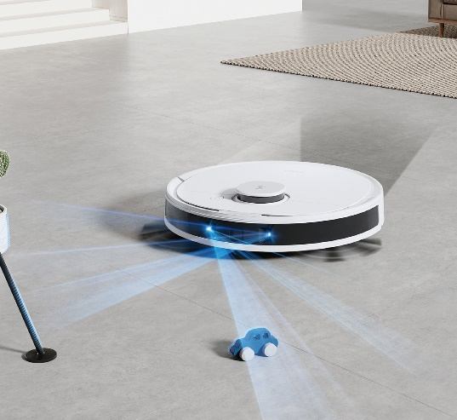

* + Explain:
    - **Robotics**: Designing machines that can perform tasks (e.g., picking up objects, moving around).
    - **AI (Artificial Intelligence)**: Teaching machines to learn and make decisions on their own (e.g., recognizing faces, playing games).
  + **Example**: Show a **video or picture of a self-driving car** and explain how it uses both robotics (to move) and AI (to make decisions).

**3. What We Learn in Robotics and AI**

**Objective: Explain why learning robotics and AI is important.**

* **Activity**:
  + Discuss how technology has always driven global progress (e.g., from the wheel to smartphones).
  + Explain that robotics and AI are now at the forefront of this progress.
  + **Visual Aid**: Show a **picture of a futuristic city** with robots and AI systems (e.g., delivery drones, smart homes).
  + Ask students: "What do you think the future will look like with more robots and AI?"

**4. What is Technology?**

**Objective: Define technology and its role in solving problems.**

* **Activity**:
  + Explain:
    - **Technology** is the application of science to solve problems.
    - It involves creating and using tools, machines, and systems to make life easier.
  + **Example**: Show a **picture of a smartphone** and ask, "How does this device solve problems in our daily lives?"
  + Discuss how technology has evolved over time (e.g., from stone tools to computers).

**5. Why Should Children Learn Technology?**

**Objective: Encourage students to think about the importance of learning technology.**

* **Activity**:
  + Ask students: "Why do you think learning robotics and AI is important?"
  + Write their answers on the board.
  + **Conclusion**: Explain that robotics and AI are the primary drivers of global innovation and industry. By learning these technologies, students can build successful and future-proof careers.
  + **Visual Aid**: Show a **picture of a diverse group of professionals** working in robotics and AI (e.g., engineers, scientists, designers).

**6. Development of Technology in Transportation**

**Objective: Show how technology has evolved to make transportation faster and more efficient.**

* **Activity**:
  + Display a **timeline of transportation modes** (walking, bicycle, motorcycle, car, train, aeroplane).
  + Discuss how each mode reduced human effort and increased speed:
    - **Walking**: 5-6 km/h (most effort).
    - **Bicycle**: 10-15 km/h (less effort).
    - **Motorcycle**: 50-250 km/h (engine-powered).
    - **Car**: 50-120 km/h (full mechanical propulsion).
    - **Train**: 80-300 km/h (minimal effort).
    - **Aeroplane**: 800-900 km/h (least effort, long distances).
  + **Visual Aid**: Show **pictures of each transportation mode** and discuss their impact on society.

**7. Industrial Revolutions**

**Objective: Explain how technology has driven major industrial revolutions.**

* **Activity**:
  + Discuss the four industrial revolutions:
    1. **First Industrial Revolution**: Steam engine (mechanization).
    2. **Second Industrial Revolution**: Electrification (mass production).
    3. **Third Industrial Revolution**: Computers and the internet (digital age).
    4. **Fourth Industrial Revolution**: Robotics and AI (automation and intelligent systems).
  + **Visual Aid**: Show a **timeline of industrial revolutions** with key inventions (e.g., steam engine, light bulb, computer, robot).
  + Ask students: "How do you think robotics and AI will change the world?"

**8. How Technology Enriches Our Daily Lives**

**Objective: Convince students of the importance of technology in their lives.**

* **Activity**:
  + Discuss how technology makes life easier, faster, and more connected.
  + **Examples**:
    - **Smartphones**: Communication, entertainment, and information at our fingertips.
    - **Smart Homes**: Lights, security, and appliances controlled by AI.
    - **Healthcare**: Robots assisting in surgeries, AI diagnosing diseases.
    - **Transportation**: Self-driving cars, electric vehicles.
  + **Visual Aid**: Show a **picture of a smart home** or a **robot assisting in surgery**.
  + Ask students: "Can you imagine a day without technology? What would it be like?"

**9. Interactive Session: Convincing Students**

**Objective: Engage students in a discussion about the impact of technology.**

* **Activity**:
  + Divide students into small groups and ask them to discuss:
    - "What is one way technology has made your life better?"
    - "What is one problem you think technology could solve in the future?"
  + Have each group share their answers with the class.
  + **Conclusion**: Emphasize that by learning robotics and AI, students can be part of creating the technologies of the future.

**10. Wrap-Up and Motivation**

**Objective: Inspire students to embrace the learning journey.**

* **Activity**:
  + Share a **quote about innovation** (e.g., "The best way to predict the future is to invent it.").
  + Encourage students to stay curious and explore the world of robotics and AI.
  + **Visual Aid**: Show a **picture of young students working on a robotics project**.

**2. Robot Introduction**

This lesson plan is designed to introduce students to the basic components of a robot, the importance of simulation software, and hands-on experiments with circuits. It includes detailed steps, visual aids (pictures), and interactive activities to ensure an engaging learning experience.

**1. How to Build a Basic Robot**

**Objective: Explain the basic components of a robot using a "compass with human" analogy.**

* **Activity**:
  + Show a **picture of a humanbody** and explain how it works

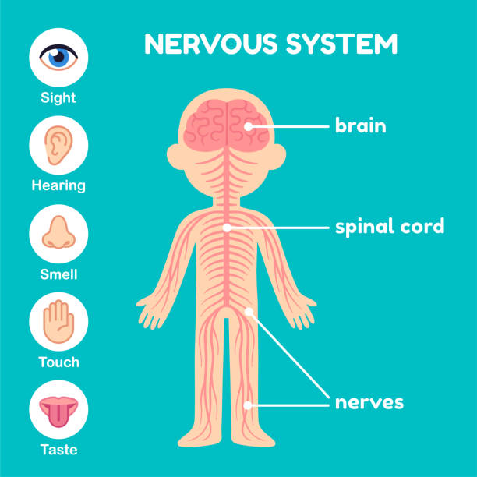

* + Compare the humanbody to a robot:
    - **Sensors** = Eyes (detect surroundings).
    - **Microcontroller** = Brain (process information).
    - **Actuators** = Hands/Feet (perform actions).
  + **Hands-On Activity**: Build a simple robot model using the kit (e.g., a car with wheels). Show a **picture of the assembled robot** as a reference.

**2. Understanding Sensors, Microcontrollers, and Actuators**

**Objective: Teach the roles of key robot components.**

* **Activity**:
  + Show a **diagram of a robot** with labeled parts (sensor, microcontroller, actuator).



* + Explain each component:
    - **Sensors**: Detect changes in the environment (e.g., light, temperature, distance).
    - **Microcontroller**: Processes sensor data and sends commands to actuators.
    - **Actuators**: Perform actions based on commands (e.g., move wheels, turn lights on/off).
  + **Example**: Demonstrate how a robot detects light and moves using a simple example.
    - Show a **picture of a light-detecting robot**.

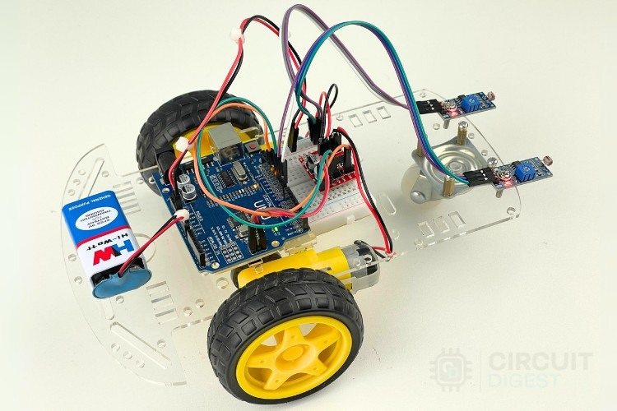

* + - Explain how the sensor detects light, the microcontroller processes the data, and the actuators move the robot.

**3. Importance of Simulation Software**

**Objective: Introduce Tinkercad as a tool for virtual experimentation.**

* **Activity**:
  + Show a **picture of Tinkercad** and explain its features:

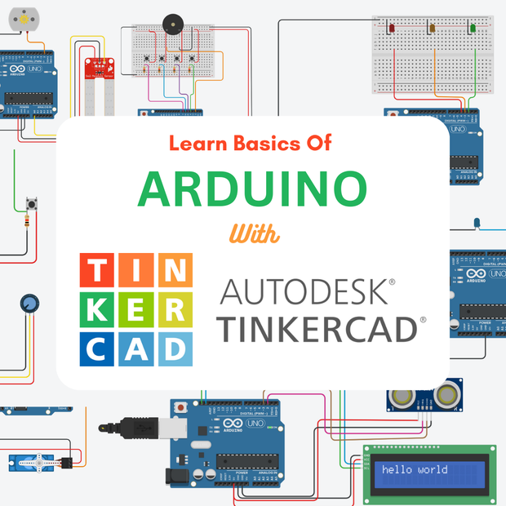

* + - Virtual breadboard for building circuits.
    - Code editor for programming.
    - Simulation mode to test circuits.
  + **Hands-On Activity**: Guide students through creating a simple circuit in Tinkercad (e.g., an LED circuit).
    - Show a **picture of the Tinkercad interface** with the circuit.



* + - Explain how to drag and drop components (LED, resistor, battery) and connect them.

**3. Experiencing Breadboard (BB)**

**Objective: Teach students how to use a breadboard.**

* **Activity**:

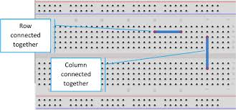

* + Explain how the breadboard works (internal connections, power rails).
  + **Hands-On Activity**: Guide students through connecting an LED, resistor, and battery on the breadboard.
    - Show a **picture of the completed circuit**.
    - Explain how to place components and connect wires.

**Resistor Introduction**

**Objective: Explain the role of resistors in circuits.**

* **Activity**:

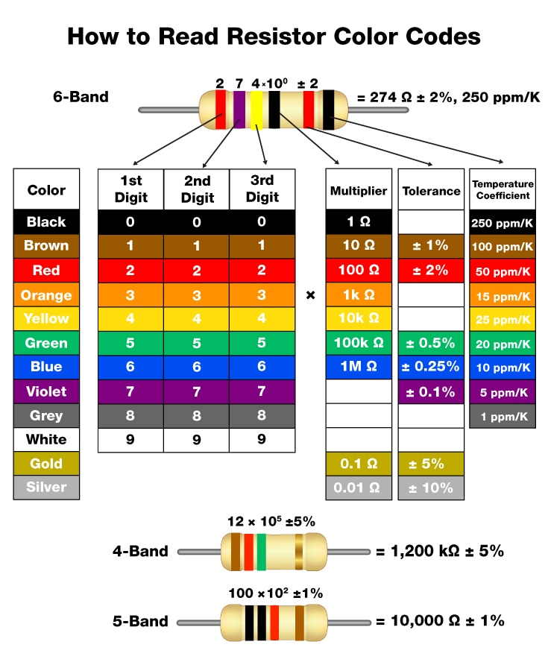

* + Explain how resistors limit current flow and protect components (e.g., LEDs).
  + **Hands-On Activity**: Let students calculate resistance using the color code.
    - Show a **picture of the resistor color code chart**.
    - Provide examples of resistors and their values.

**Arduino Introduction**

**Objective: Introduce Arduino and its everyday uses.**

* **Activity**:
  + Show a **picture of an Arduino board** and explain its components (e.g., digital pins, analog pins, power supply).
  + Discuss examples of Arduino in real life (e.g., smart home systems, robotics).
  + **Hands-On Activity**: Guide students through connecting an LED to an Arduino and uploading a simple "Blink" program.

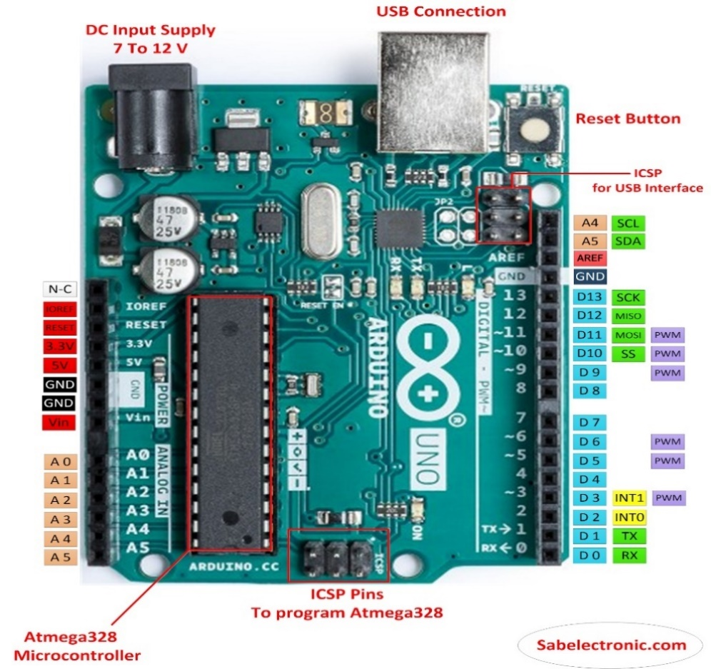

**4. Programming Arduino**

**Objective: Introduce students to Arduino programming.**

**How to install Arduino IDE?**

**Download the Arduino Software (IDE)**

Get the latest version from the [download page](https://www.arduino.cc/en/Main/Software). You can choose between the Installer (.exe) and the Zip packages. We suggest you use the first one that installs directly everything you need to use the Arduino Software (IDE), including the drivers. With the Zip package you need to install the drivers manually. The Zip file is also useful if you want to create a [portable installation](https://arduino.cc/en/Guide/PortableIDE).

When the download finishes, proceed with the installation and please allow the driver installation process when you get a warning from the operating system.

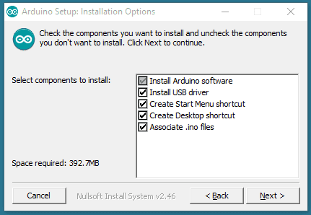**Choose the components to install.**

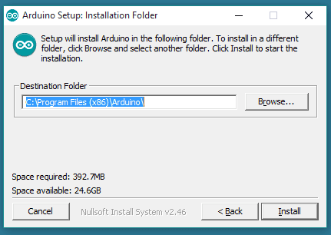**Choose the installation directory.**

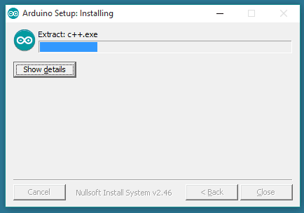**Installation in progress.**

The process will extract and install all the required files to execute properly the Arduino Software (IDE)

**Objective: Teach students how to write and upload code.**

**Blink Code in Tinkercad:**

* **Activity**:

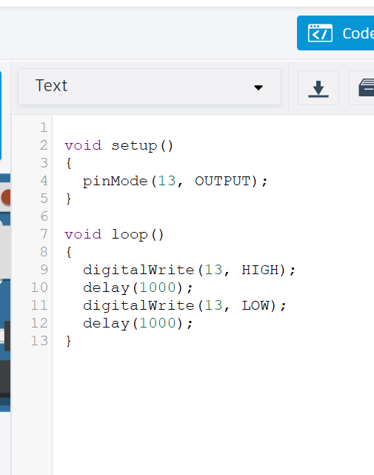

* + Explain the code structure (e.g., setup(), loop(), digitalWrite()).
  + **Hands-On Activity**: Guide students through writing and uploading the code to a virtual Arduino.

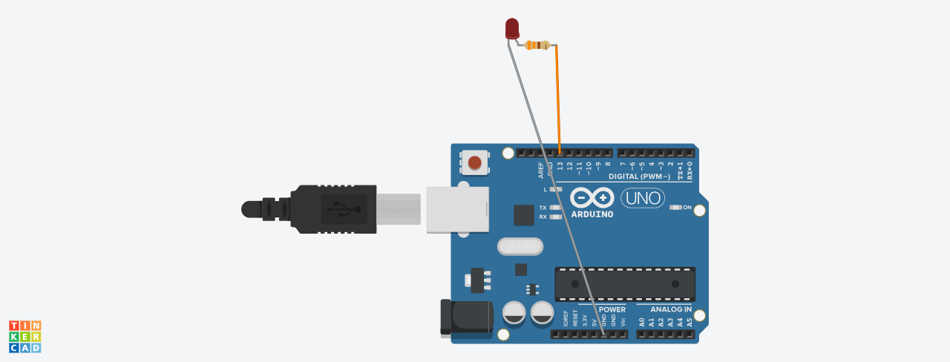

**5. Experimenting with Different Tasks Using LEDs**

**Objective: Teach students how to control LEDs in various ways, such as creating patterns, adjusting brightness, and integrating sensors.**

**Task 1: Blinking 3 LEDs Simultaneously**

**Objective:** Turn three LEDs on and off together at the same time.

* **Activity**:
  + Show a **picture of an LED pattern**

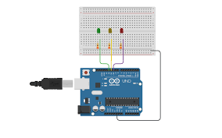

* + Guide students through writing code to create patterns (e.g., blink two LEDs alternately).

**Example Code:**

void setup() {

pinMode(3, OUTPUT);

pinMode(4, OUTPUT);

pinMode(5, OUTPUT);

}

void loop() {

digitalWrite(3, HIGH);

digitalWrite(4, HIGH);

digitalWrite(5, HIGH);

delay(500);

digitalWrite(3, LOW);

digitalWrite(4, LOW);

digitalWrite(5, LOW);

delay(500);

}

**Task 2: LED Patterns**

* **Objective**: Create different LED blinking patterns.
* **Activity**:
  + Show a **picture of an LED pattern** (e.g., alternating blink, sequential blink).

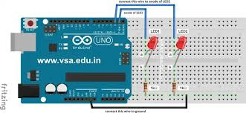

* + Guide students through writing code to create patterns (e.g., blink two LEDs alternately).
  + **Example Code**:

void setup() {

pinMode(2, OUTPUT);

pinMode(3, OUTPUT);

}

void loop() {

digitalWrite(2, HIGH);

digitalWrite(3, LOW);

delay(500);

digitalWrite(2, LOW);

digitalWrite(3, HIGH);

delay(500);

}

**Task 3: LED Running Light (Chasing Effect)**

**Objective:** Create a running light effect with multiple LEDs.

**Activity:**

* **Show a picture** of a running light circuit with multiple LEDs.

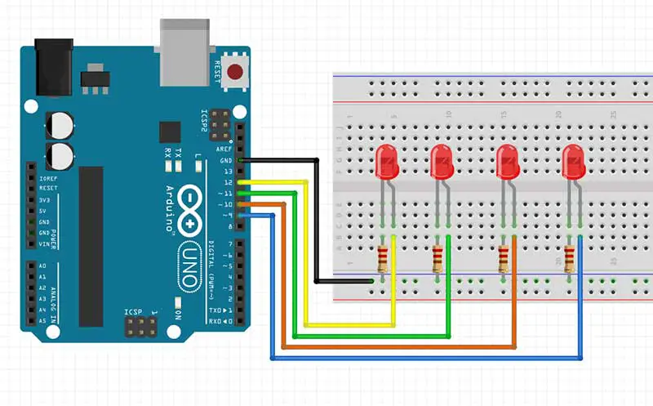

* **Guide students** through writing code for a simple LED chasing effect.

**Example Code:**

void setup() {

pinMode(9,OUTPUT);

pinMode(10,OUTPUT);

pinMode(11,OUTPUT);

pinMode(12,OUTPUT);

}

void loop() {

digitalWrite(12,LOW);

digitalWrite(9,HIGH);

delay(500);

digitalWrite(9,LOW);

digitalWrite(10,HIGH);

delay(500);

digitalWrite(10,LOW);

digitalWrite(11,HIGH);

delay(500);

digitalWrite(11,LOW);

digitalWrite(12,HIGH);

delay(500);

}

**Task 4: LED Knight Rider Effect**

**Objective:** Set of LEDs that blinks one after another **Activity:**

* **Show a picture** of a Knight Rider LED setup.

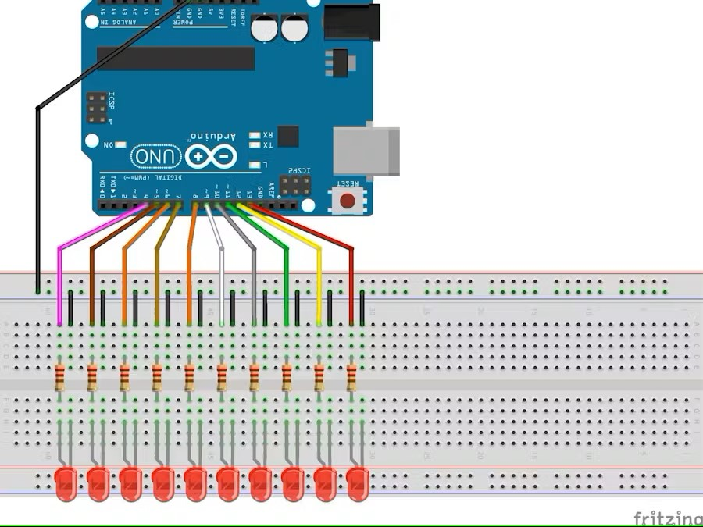

* **Guide students** through writing code for this effect.

**Example Code:**

void setup() {

pinMode(13, OUTPUT);

pinMode(12, OUTPUT);

pinMode(11, OUTPUT);

pinMode(10, OUTPUT);

pinMode(9, OUTPUT);

pinMode(8, OUTPUT);

pinMode(7, OUTPUT);

pinMode(6, OUTPUT);

pinMode(5, OUTPUT);

pinMode(4, OUTPUT);

}

void loop() {

digitalWrite(13, HIGH);

delay(50);

digitalWrite(13, LOW);

digitalWrite(12, HIGH);

delay(50);

digitalWrite(12, LOW);

digitalWrite(11, HIGH);

delay(50);

digitalWrite(11, LOW);

digitalWrite(10, HIGH);

delay(50);

digitalWrite(10, LOW);

digitalWrite(9, HIGH);

delay(50);

digitalWrite(9, LOW);

digitalWrite(8, HIGH);

delay(50);

digitalWrite(8, LOW);

digitalWrite(7, HIGH);

delay(50);

digitalWrite(7, LOW);

digitalWrite(6, HIGH);

delay(50);

digitalWrite(6, LOW);

digitalWrite(5, HIGH);

delay(50);

digitalWrite(5, LOW);

digitalWrite(4, HIGH);

delay(50);

digitalWrite(4, LOW);

digitalWrite(4, HIGH);

delay(50);

digitalWrite(4, LOW);

digitalWrite(5, HIGH);

delay(50);

digitalWrite(5, LOW);

digitalWrite(6, HIGH);

delay(50);

digitalWrite(6, LOW);

digitalWrite(7, HIGH);

delay(50);

digitalWrite(7, LOW);

digitalWrite(8, HIGH);

delay(50);

digitalWrite(8, LOW);

digitalWrite(9, HIGH);

delay(50);

digitalWrite(9, LOW);

digitalWrite(10, HIGH);

delay(50);

digitalWrite(10, LOW);

digitalWrite(11, HIGH);

delay(50);

digitalWrite(11, LOW);

digitalWrite(12, HIGH);

delay(50);

digitalWrite(12, LOW);

digitalWrite(13, HIGH);

delay(50);

digitalWrite(13, LOW);

}

**6. Traffic Light Project**

**Objective: Apply knowledge to a real-world project.**

* **Activity**:
  + Show a **picture of a traffic light** and explain its components.

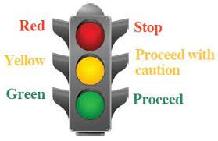

* + Guide students through building and programming a traffic light model using LEDs and Arduino.
    - Show a **picture of the completed traffic light model**.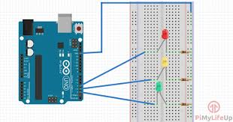
    - Explain the code for controlling the LEDs (red, yellow, green).

**7. Experiments with Capacitors and Sensors**

**Objective: Teach students about capacitors and their uses in electronic circuits.**

* **Activity**:
  + Show a **picture of a capacitor** and explain how it stores energy.

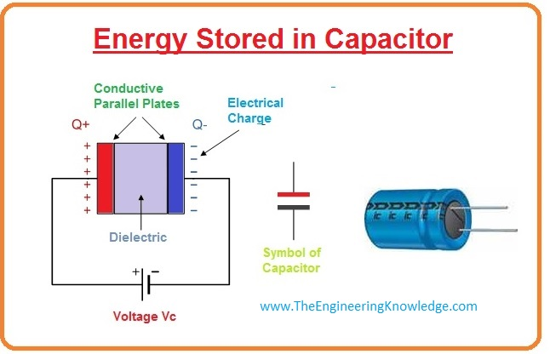

* + Demonstrate a simple capacitor circuit on a breadboard.

**Detailed Explanation**

**1. What is a Capacitor?**

* **Definition**: A capacitor is an electronic component that stores electrical energy in an electric field.
* **How It Works**:
  + When connected to a power source, the capacitor charges up and stores energy.
  + When the power source is removed, the capacitor discharges, releasing the stored energy.
* **Types of Capacitors**:
  + **Electrolytic Capacitors**: Polarized (has positive and negative terminals), used for higher capacitance values.
  + **Ceramic Capacitors**: Non-polarized, used for smaller capacitance values.

**2. Capacitor Circuit Setup**

* **Components Needed**:
  + 1 x Capacitor (e.g., 100µF electrolytic capacitor).
  + 1 x LED.
  + 1 x Resistor (220Ω for the LED).
  + 1 x Push Button.
  + Breadboard and connecting wires.
* **Circuit Diagram**:

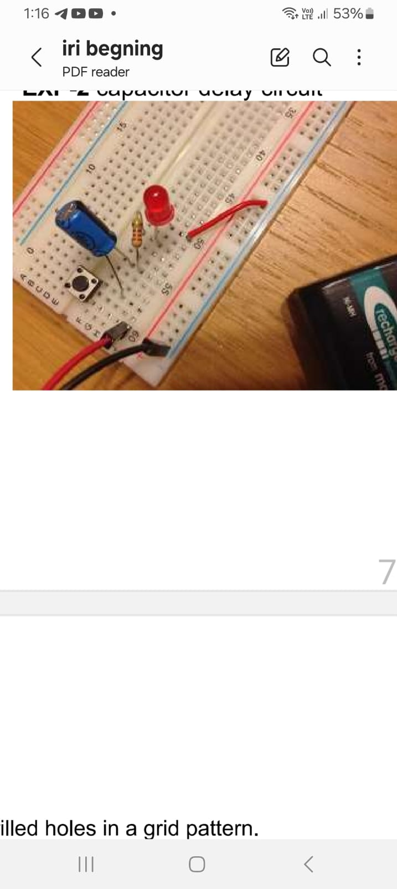

Connect the capacitor's positive terminal to the **5V** pin of the Arduino.

* + Connect the capacitor's negative terminal to **GND**.
  + Connect the LED's anode (long leg) to the capacitor's positive terminal through a 220Ω resistor.
  + Connect the LED's cathode (short leg) to **GND**.
  + Connect a push button between the capacitor's positive terminal and **GND**.

**3. How It Works**

* When the button is pressed, the capacitor charges up and stores energy.
* When the button is released, the capacitor discharges through the LED, causing it to light up briefly.

**4. Hands-On Activity**

1. **Build the Circuit**:
   * Show students how to connect the capacitor, LED, and push button to the breadboard.
   * Use a **picture of the circuit** as a reference.
2. **Test the Circuit**:
   * Press the button to charge the capacitor.
   * Release the button and observe how the LED lights up as the capacitor discharges.
3. **Experiment with Different Capacitors**:
   * Replace the capacitor with different values (e.g., 10µF, 470µF) and observe how the LED's brightness and duration change.

**6. Discussion and Applications**

* **Real-World Applications**:
  + Power backup in electronic devices.
  + Filtering noise in power supplies.
  + Timing circuits (e.g., in blinking LEDs).
* **Discussion Questions**:
  + What happens if you use a larger capacitor?
  + How does the resistor affect the LED's brightness and duration?
  + Can you think of other devices that use capacitors?

**8. Working with IR module**

**Objective: Teach students how to build an IR Proximity Sensor circuit and write code to control an LED based on sensor input.**

* + **Activity**:
    - Show a **picture of an IR module**  and explain how it works.

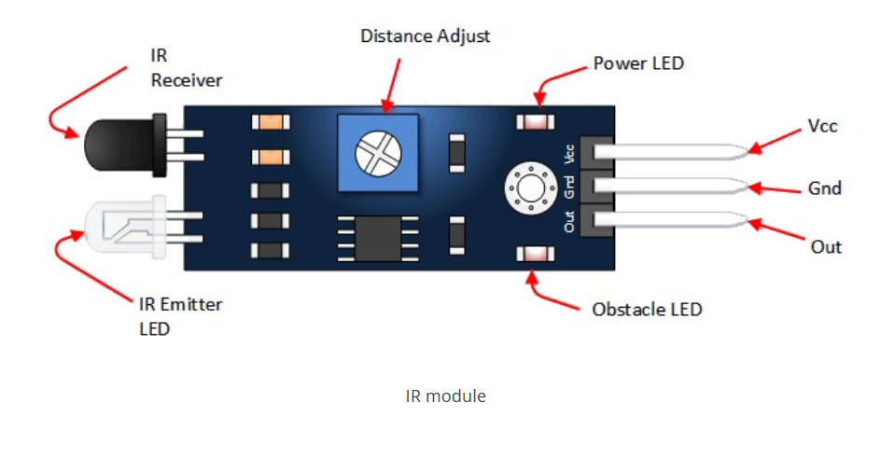

* + - Demonstrate how to build the circuit and write the code.

**Detailed Explanation**

**1. What is an IR Proximity Sensor?**

* + **Definition**: An IR (Infrared) Proximity Sensor detects objects by emitting infrared light and measuring the reflection.
  + **How It Works**:
    - The sensor emits infrared light and detects the reflected light from an object.
    - The output is a digital signal (HIGH or LOW) indicating whether an object is detected.

**2. IR Proximity Sensor Circuit Setup**

* + **Components Needed**:
    - 1 x IR Proximity Sensor (e.g., TCRT5000).
    - 1 x LED.
    - 1 x Resistor (220Ω for the LED).
    - Breadboard and connecting wires.
    - Arduino Uno.
  + **Circuit Diagram**:

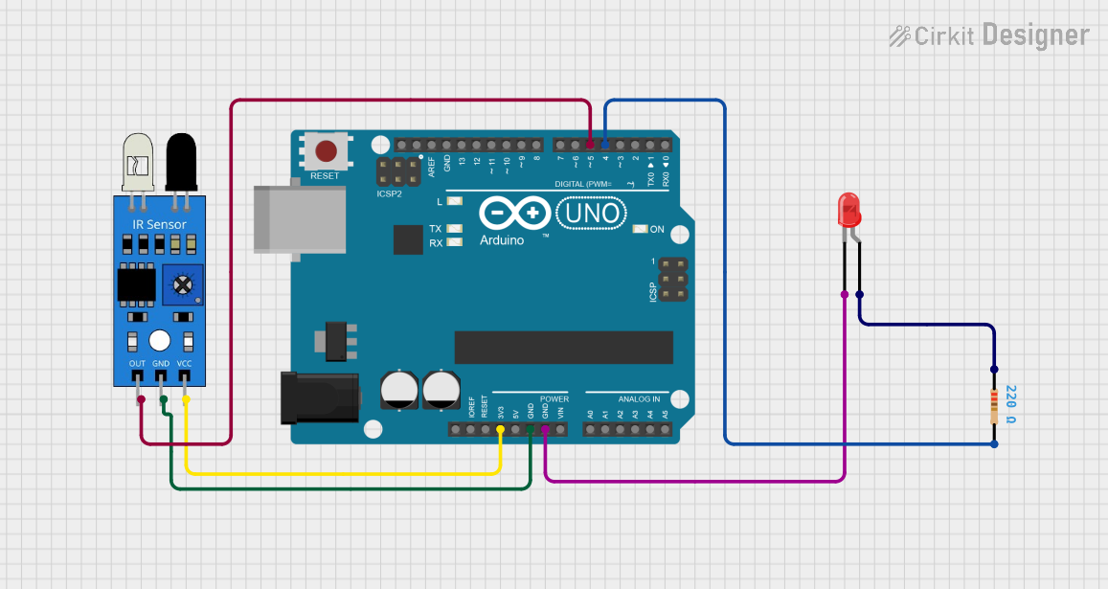

* + - Connect the IR sensor's **VCC** pin to **5V** on the Arduino.
    - Connect the IR sensor's **GND** pin to **GND** on the Arduino.
    - Connect the IR sensor's **OUT** pin to **digital pin 2** on the Arduino.
    - Connect the LED's anode (long leg) to **digital pin 9** through a 220Ω resistor.
    - Connect the LED's cathode (short leg) to **GND**.

**3. How It Works**

* + When an object is detected, the IR sensor's output goes **LOW**.
  + The Arduino reads this signal and turns on the LED.
  + When no object is detected, the IR sensor's output goes **HIGH**, and the LED turns off.

**4. Hands-On Activity**

* 1. **Build the Circuit**:
     + Show students how to connect the IR sensor and LED to the Arduino.
     + Use a **picture of the circuit** as a reference.
  2. **Upload the Code**:
     + Guide students through writing and uploading the code.
     + **Example Code**:

void setup() {

pinMode(2, INPUT);

pinMode(9, OUTPUT);

}

void loop() {

int x = digitalRead(2);

if (x == LOW) {

digitalWrite(9, HIGH);

} else {

digitalWrite(9, LOW);

}

}

* 1. **Test the Circuit**:
     + Place an object in front of the IR sensor and observe the LED turning on.
     + Remove the object and observe the LED turning off.

**5. Discussion and Applications**

* + **Real-World Applications**:
    - Object detection in robotics.
    - Proximity sensing in automatic doors.
    - Line following robots.
  + **Discussion Questions**:
    - What happens if you reverse the IR sensor's connections?
    - How can you modify the code to make the LED blink when an object is detected?
    - Can you think of other sensors that could be used for object detection?

**Task 2: Digital Read Concept & If Condition**

**Objective: Teach students about the digitalRead() function and if conditions in Arduino programming.**

* + **Activity**:
    - Show a **picture of a flowchart** explaining the if condition.

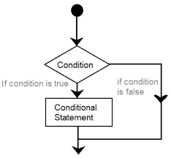

* + - Explain how the digitalRead() function works.
    - Guide students through writing and testing the code.

**1. Digital Read Concept**

* + **Definition**: The digitalRead() function reads the state of a digital pin (HIGH or LOW).
  + **How It Works**:
    - When the pin is HIGH, digitalRead() returns HIGH.
    - When the pin is LOW, digitalRead() returns LOW.

**2. If Condition**

* + **Definition**: The if condition executes a block of code if a specified condition is true.
  + **How It Works**:
    - If the condition is true, the code inside the if block is executed.
    - If the condition is false, the code inside the else block (if present) is executed.

**3. Hands-On Activity**

* 1. **Write the Code**:
     + Guide students through writing the code to control the LED based on the IR sensor's output.
     + **Example Code**:

void setup() {

pinMode(2, INPUT);

pinMode(9, OUTPUT);

Serial.begin(9600);

}

void loop() {

int x = digitalRead(2);

Serial.print("x: ");

Serial.println(x);

if (x == LOW) {

digitalWrite(9, HIGH);

} else {

digitalWrite(9, LOW);

}

}

* 1. **Test the Code**:
     + Upload the code to the Arduino and test the circuit.
     + Observe how the LED turns on/off based on the IR sensor's output.

**Task 3 : Two IR Sensors and two LEDs**

**Objective: Teach students how to use 2 IR sensors to control 2 LEDs independently based on object detection.**

* **Activity**:
  + Show a **picture of the circuit** with 2 IR sensors and 2 LEDs.
  + Demonstrate how to build the circuit and write the code.

**Detailed Explanation**

**1. What is an IR Proximity Sensor?**

* **Definition**: An IR (Infrared) Proximity Sensor detects objects by emitting infrared light and measuring the reflection.
* **How It Works**:
  + The sensor emits infrared light and detects the reflected light from an object.
  + The output is a digital signal (HIGH or LOW) indicating whether an object is detected.

**2. Circuit Setup**

* **Components Needed**:
  + 2 x IR module
  + 2 x LEDs.
  + 2 x Resistors (220Ω for the LEDs).
  + Breadboard and connecting wires.
  + Arduino Uno.
* **Circuit Diagram**:

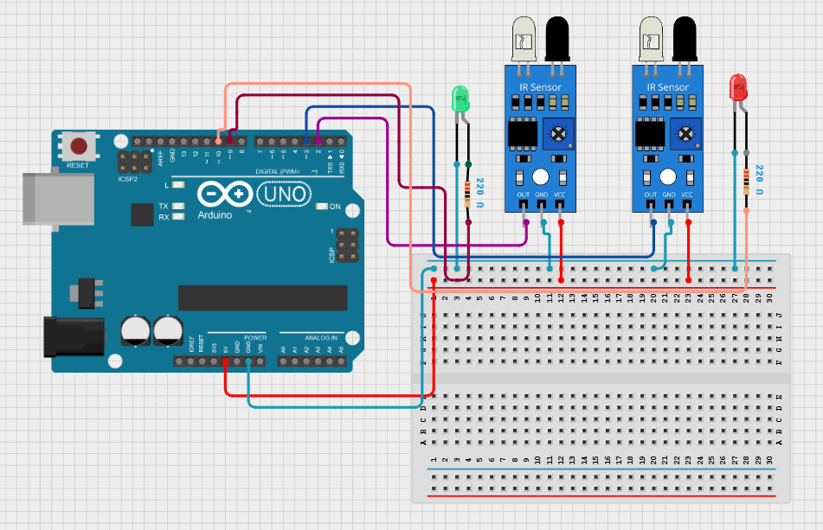

* + **IR Sensor 1**:
    - Connect the **VCC** pin to **5V** on the Arduino.
    - Connect the **GND** pin to **GND** on the Arduino.
    - Connect the **OUT** pin to **digital pin 2** on the Arduino.
  + **IR Sensor 2**:
    - Connect the **VCC** pin to **5V** on the Arduino.
    - Connect the **GND** pin to **GND** on the Arduino.
    - Connect the **OUT** pin to **digital pin 3** on the Arduino.
  + **LED 1**:
    - Connect the anode (long leg) to **digital pin 9** through a 220Ω resistor.
    - Connect the cathode (short leg) to **GND**.
  + **LED 2**:
    - Connect the anode (long leg) to **digital pin 10** through a 220Ω resistor.
    - Connect the cathode (short leg) to **GND**.

**3. How It Works**

* When an object is detected by **IR Sensor 1**, **LED 1** turns on.
* When an object is detected by **IR Sensor 2**, **LED 2** turns on.
* If no object is detected, the corresponding LED turns off.

**4. Hands-On Activity**

1. **Build the Circuit**:
   * Show students how to connect the 2 IR sensors and 2 LEDs to the Arduino.
   * Use a **picture of the circuit** as a reference.
2. **Upload the Code**:
   * Guide students through writing and uploading the code.
   * **Example Code**:

void setup() {

pinMode(2, INPUT);

pinMode(3, INPUT);

pinMode(9, OUTPUT);

pinMode(10, OUTPUT);

}

void loop() {

if (digitalRead(2) == LOW) {

digitalWrite(9, HIGH);

}

else {

digitalWrite(9, LOW);

}

if (digitalRead(3) == LOW) {

digitalWrite(10, HIGH);

}

else {

digitalWrite(10, LOW); // Turn off LED 2

}

}

1. **Test the Circuit**:
   * Place an object in front of **IR Sensor 1** and observe **LED 1** turning on.
   * Place an object in front of **IR Sensor 2** and observe **LED 2** turning on.
   * Remove the objects and observe the LEDs turning off.

**5. Discussion and Applications**

* + **Real-World Applications**:
    - Automatic lighting systems.
    - Security systems.
    - Interactive displays.

**9. LDR Module Experiments**

**Objective:**  
Teach students how to experiment with an LDR (Light Dependent Resistor) module, automate a street light system, and create a simple morning alarm using Arduino for digital control, utilizing only digital pins for input and output.

**Experiment with LDR Module (Digital Simulation)**

**What is an LDR Module?**

* **Definition:** An LDR (Light Dependent Resistor) module is a sensor module that includes an LDR, along with necessary circuitry, to simplify light sensing. The module changes its output state based on the amount of light falling on it.

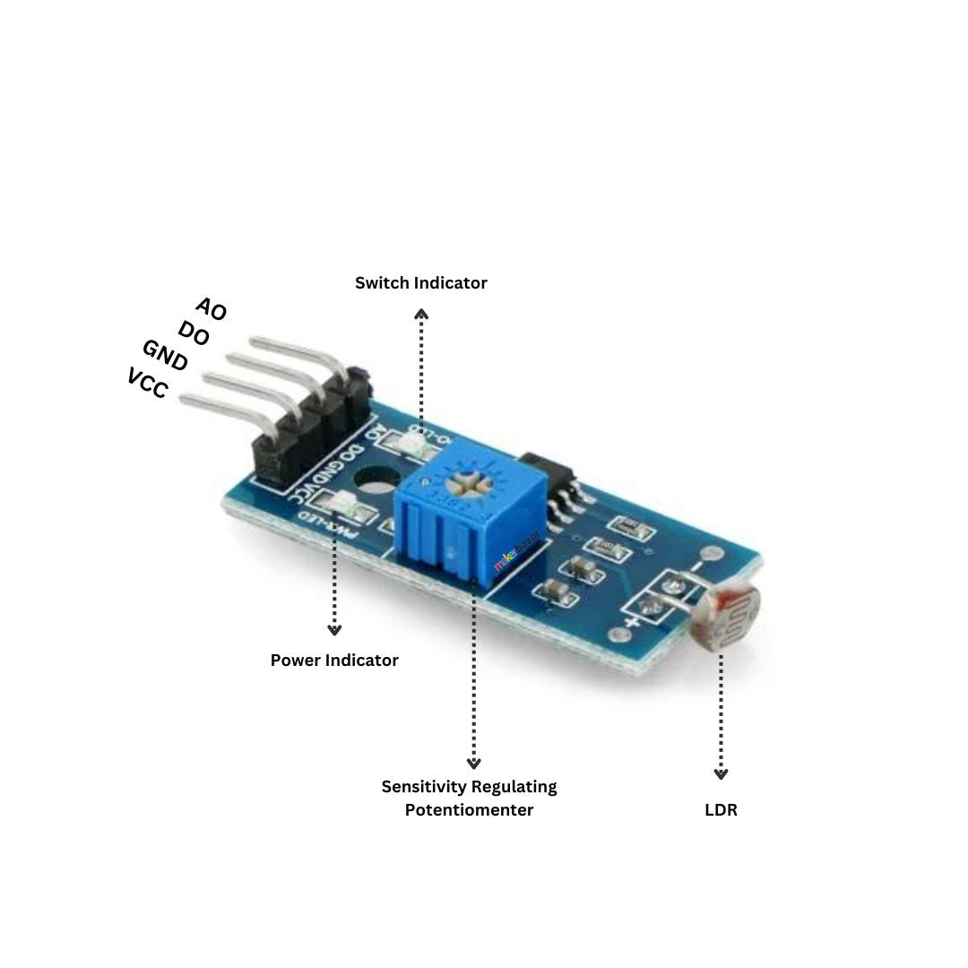

* **How It Works:**
  + In bright light, the module's output state changes (typically to HIGH or LOW depending on the module’s design).
  + In darkness, the module's output state changes to the opposite state.
  + This property makes it useful for light-sensing applications.

**Simple Experiment with LDR Module and LED (Using Arduino)**

**Components Needed:**

* 1 x LDR Module
* 1 x LED
* Arduino Uno
* Breadboard and connecting wires

**Circuit Setup:**

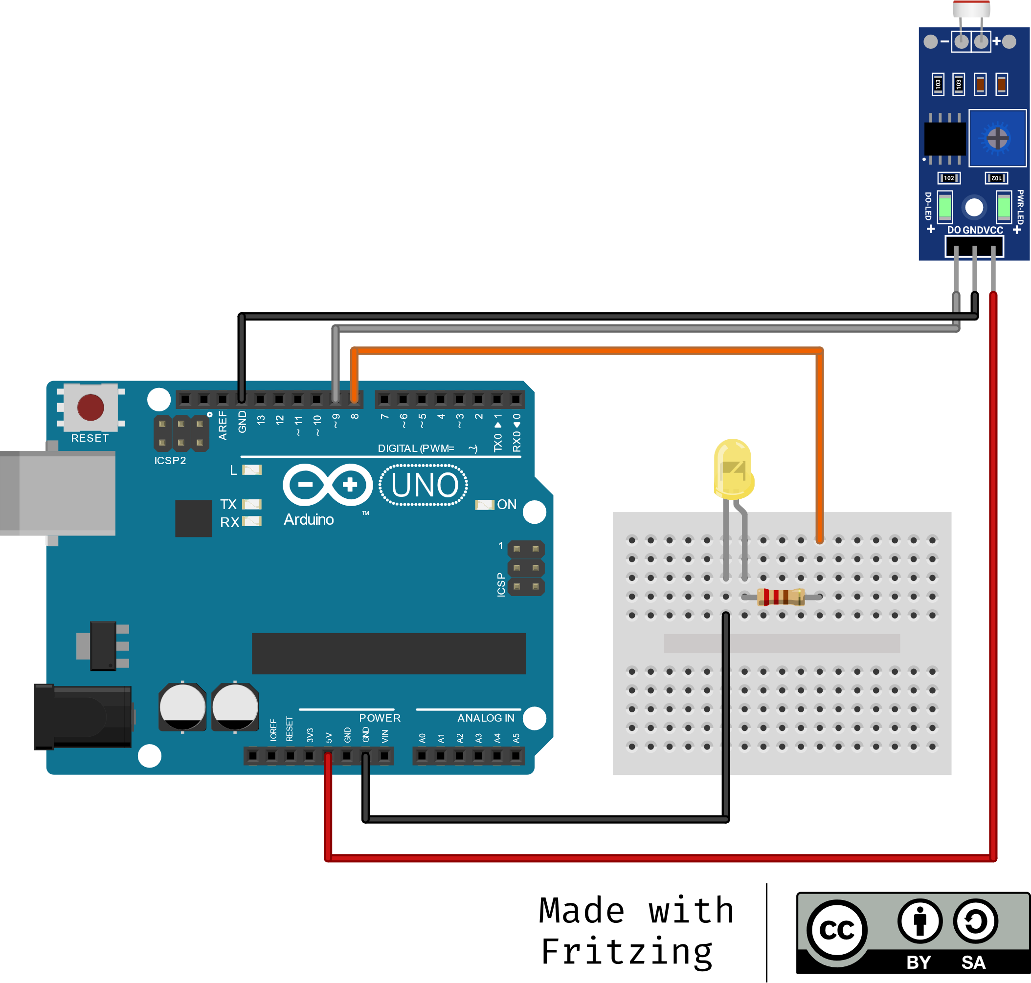

* Connect the LDR module's **VCC** pin to the **5V** pin of the Arduino.
* Connect the LDR module's **GND** pin to the **GND** pin of the Arduino.
* Connect the LDR module's **OUT** pin to a **digital pin (e.g., D9)** on the Arduino.
* Connect the **anode (long leg)** of the LED to a **digital pin (e.g., D8)** on the Arduino.
* Connect the **cathode (short leg)** of the LED to **GND** pin of the Arduino.

**Arduino Code:**

void setup() {

 pinMode(8, OUTPUT);

 pinMode(9, INPUT);

}

void loop() {

 if(digitalRead(9)) {

   digitalWrite(8, HIGH);

 } else {

   digitalWrite(8, LOW);

 }

}

**Automating a Street Light System**

**Concept Overview:**  
Create an automatic street light that turns on at night and off during the day using an LDR module and Arduino.

**Working Principle:**

* In daylight, the LDR module's output is in one state, and the LED remains off.
* At night, the LDR module's output changes, and the LED turns on.

**Hands-On Activity:**

1. **Build the Circuit:** Use the same circuit as the LDR module and LED experiment.
2. **Test the System:**
   * Cover the LDR module to simulate night and observe the LED turning on.
   * Expose the LDR module to bright light and observe the LED turning off.

**Discussion and Applications:**

* **Real-World Uses:**
  + Automatic street lights
  + Solar-powered garden lights
  + Energy-efficient lighting systems
* **Discussion Questions:**
  + How can you adjust the sensitivity of the LDR module?
  + How can you add a delay before turning the LED on?

**Morning Alarm Using LDR Module and Buzzer (Using Arduino)**

**Concept Overview:**  
Create a morning alarm that activates when daylight is detected using an LDR module and a buzzer.

**Components Needed:**

* 1 x LDR Module
* 1 x Buzzer
* Arduino Uno
* Breadboard and connecting wires

**Circuit Setup:**

* Connect the LDR module's **VCC** pin to the **5V** pin of the Arduino.
* Connect the LDR module's **GND** pin to the **GND** pin of the Arduino.
* Connect the LDR module's **OUT** pin to a **digital pin (e.g., D9)** on the Arduino.
* Connect the **anode (long leg)** of the buzzer to a **digital pin (e.g., D8)** on the Arduino.
* Connect the **cathode (short leg)** of the buzzer to **GND** pin of the Arduino.

**Arduino Code:**

void setup() {

pinMode(9, INPUT);

pinMode(8, OUTPUT);

}

void loop() {

int ldrValue = digitalRead(9);

if (ldrValue == HIGH) {

digitalWrite(8, HIGH);

delay(1000);

digitalWrite(8, LOW);

delay(500);

} else {

digitalWrite(8, LOW);

}

delay(100);

}

**How It Works:**

* When the light level increases (e.g., in the morning), the LDR module's output changes, and the Arduino turns on the buzzer.
* When the light level decreases (e.g., at night), the LDR module's output changes back, and the Arduino turns off the buzzer.

**Hands-On Activity:**

1. **Build the Circuit:** Use the same circuit as above.
2. **Test the System:**
   * Use a flashlight or cover the LDR module to simulate day and night.
   * Observe how the buzzer turns on and off based on light conditions.

**Discussion and Applications:**

* **Real-World Uses:**
  + Automatic wake-up alarms
  + Smart lighting systems
* **Discussion Questions:**
  + How can you add a delay before activating the alarm?
  + Can this system be integrated with a microcontroller for more complex control?

**10. Switch Experiment**

**Objective:** Teach students how to experiment with a switch, understand its role in controlling electrical circuits, automate a doorbell system, and create a simple digital control mechanism using a switch.

**1. What is a Switch?**

* **Definition:** A switch is an electrical component that controls the flow of current in a circuit.

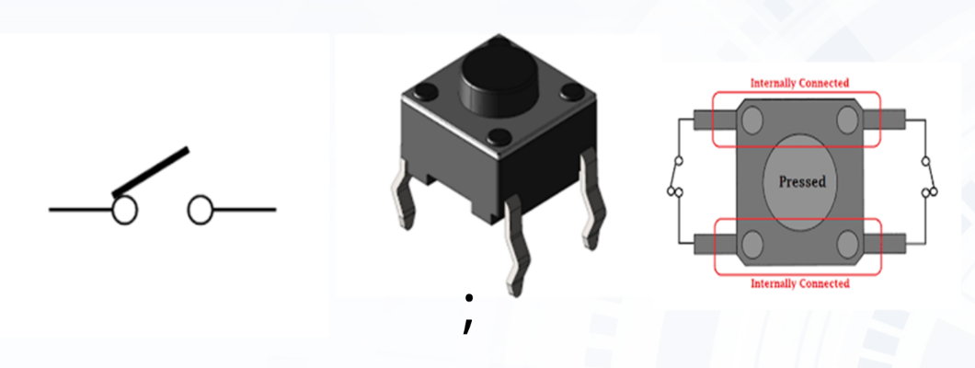

* **How It Works:**
  + When the switch is closed (pressed), it completes the circuit, allowing current to flow.
  + When the switch is open (released), it breaks the circuit, stopping current flow.
  + Switches are used in various applications like lights, fans, alarms, and electronic devices.

**2. Simple Experiment with LED and Switch (Arduino Code)**

* **Components Needed:**
  + 1 x LED
  + 1 x Resistor (220Ω or 330Ω)
  + 1 x Push Button (Switch)
  + Arduino Uno
  + Breadboard and connecting wires
* **Circuit Setup (Arduino):**

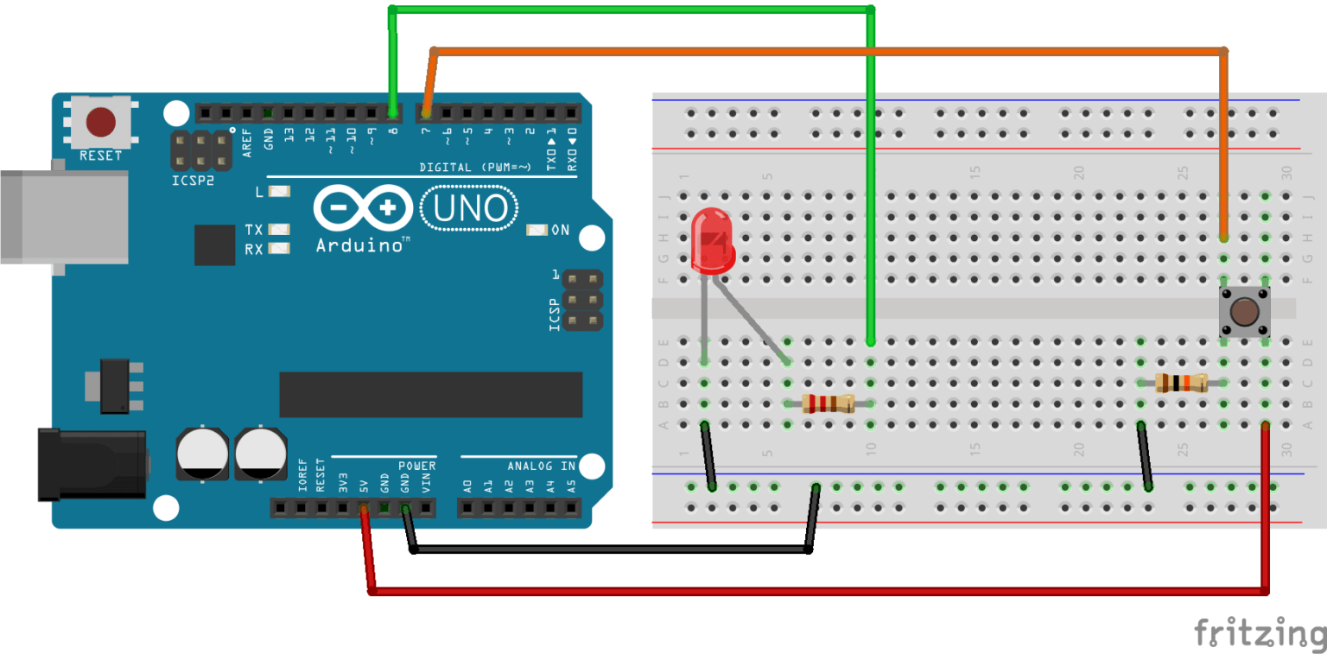

* + Connect one leg of the push button to 5V on the Arduino.
  + Connect the other leg of the button to a digital pin (e.g., D7) and a 10kΩ resistor to GND.
  + Connect the anode (long leg) of the LED to a digital pin (e.g., D8) through a 220Ω or 330Ω resistor.
  + Connect the cathode (short leg) of the LED to digital GND on the Arduino.
* **Arduino Code:**

void setup() {

pinMode(8, OUTPUT);

pinMode(7, INPUT);

}

void loop() {

int buttonState = digitalRead(7);

if (buttonState == HIGH) {

digitalWrite(8, HIGH);

} else {

digitalWrite(8, LOW);

}

}

* **How It Works:**
  + The INPUT_PULLUP mode makes the pin read HIGH when the switch is open.
  + When the switch is pressed, it connects the pin to GND, making it read LOW.
  + The code turns the LED on when the switch is pressed and off when it's released.
* **Hands-On Activity:**
  + Press the switch and observe the LED turning ON and OFF.
  + Modify the circuit to include two LEDs—one that turns ON when the switch is pressed, and another that turns ON when the switch is released.

**2. Simple Experiment with Switch and Buzzer (Arduino Code)**

* **What is a Buzzer?**
  + A buzzer is an electronic component that produces sound when electricity flows through it.
  + Used in alarms, doorbells, and notifications.
* **Components Needed:**
  + 1 x Buzzer
  + 1 x Push Button
  + Arduino Uno
  + Breadboard and connecting wires
* **Circuit Setup (Arduino):**

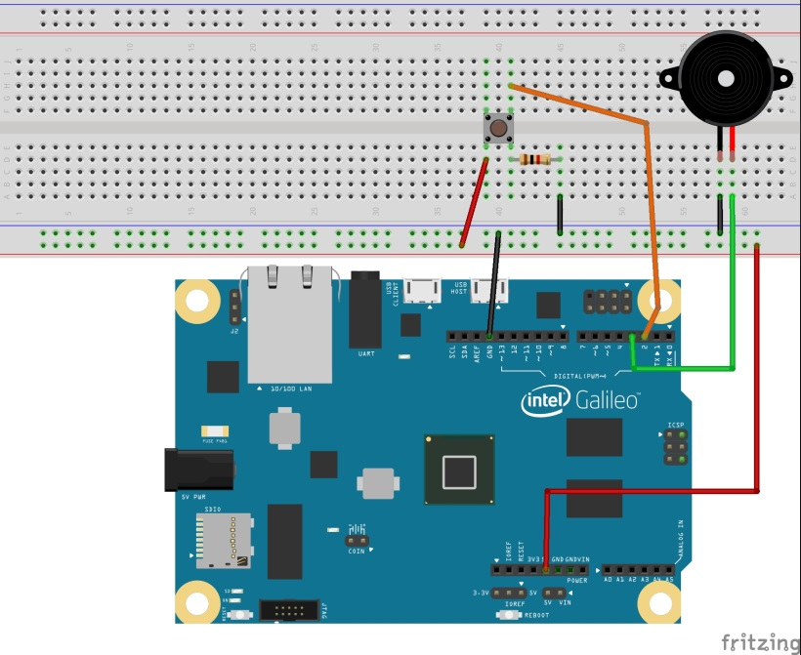

* + Connect one leg of the push button to 5V on the Arduino.
  + Connect the other leg of the button to a digital pin (e.g., D2) and a 10kΩ resistor to GND.
  + Connect the positive terminal of the buzzer to a digital pin (e.g., D11).
  + Connect the negative terminal of the buzzer to digital pin (e.g., D12) on the Arduino.
* **Arduino Code:**

void setup() {

pinMode(2, INPUT_PULLUP);

pinMode(3, OUTPUT);

}

void loop() {

int x= digitalRead(2);

if (x== LOW) {

digitalWrite(3, HIGH);

} else {

digitalWrite(3, LOW);

}

}

* **How It Works:**
  + The code works similarly to the LED example, turning the buzzer on when the switch is pressed.
* **Hands-On Activity:**
  + Press the switch and hear the buzzer sound.
  + Release the switch to stop the buzzer.
  + Modify the circuit to make the buzzer stay ON even after releasing the switch (Hint: Use a toggle mechanism).

**5. Discussion and Applications**

* **Real-World Uses:**
  + Switches in appliances (TV remotes, fans, lights).
  + Doorbell systems.
  + Keyboards and calculators.
  + Digital locks and security systems.

**11. Multiple LED Control & Integration of IR and LDR with If-ElseIf Statements**

**Objective**By the end of this lesson, students will:  
• Understand how to control multiple LEDs using IR sensors and an LDR.  
• Learn to implement if-elseif conditional statements in Arduino programming.  
• Build a smart street light system that automatically turns on LEDs based on light intensity and motion detection.

**Introduction**

**Concept Overview**

**•** Energy-Efficient System: Uses Arduino, LDR, and IR sensors to optimize power usage.  
• Automatic Light Control: LDR turns street lights on at night and off during the day.  
• Motion Detection: IR sensors activate lights only when movement is detected.  
• Cost-Effective & Safe: Reduces energy consumption, operational costs, and overheating risks.  
• Smart Lighting: Uses simple electronic components for an effective lighting solution.

**Required Components**

**•** Arduino Uno  
• Two IR sensors  
• One LDR module  
• Two LEDs  
• One 1KΩ resistor (for the LDR module)  
• Two 220Ω resistors (for LEDs)  
• Jumper wires  
• Breadboard

**Interfacing the Components with Arduino**

**Circuit Setup (Arduino):**

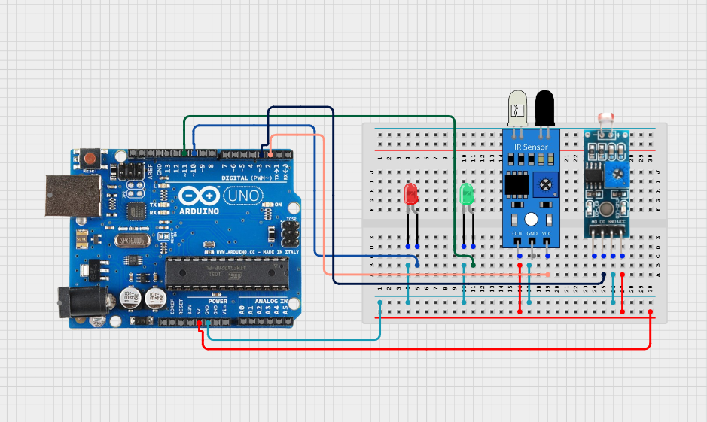

IR Sensors  
• VCC → Arduino 5V  
• GND → Arduino GND  
• OUT1 (IR1) → Digital pin 2  
• OUT2 (IR2) → Digital pin 3

LDR Module  
• One leg to 5V, the other to A3 (with a 1KΩ pull-down resistor to GND)

LEDs  
• LED1 (IR1 control) → Digital pin 10  
• LED2 (IR2 control) → Digital pin 11  
• Both LEDs need a 220Ω resistor in series

**Example Code:**

void setup() {

pinMode(2, INPUT);

pinMode(3, INPUT);

pinMode(10, OUTPUT);

pinMode(11, OUTPUT);

Serial.begin(9600);

}

void loop() {

if (digitalRead(2) == LOW) {

digitalWrite(10, HIGH);

} else {

digitalWrite(10, LOW);

}

if (digitalRead(3) == LOW) {

digitalWrite(11, HIGH);

} else {

digitalWrite(11, LOW);

}

Serial.print("LDR: ");

Serial.println(digitalRead(3));

delay(100);

}

**Code Explanation**

1. Reads IR sensor values (digital input 2 and 3) to detect motion.
2. Turns on the respective LED when an IR sensor detects motion.
3. Serial Monitor Output shows IR sensor values and LED status.
4. Delay added to reduce processing load.

**Hands-on Activity & Testing**

• Step 1: Assemble the circuit as per the wiring diagram.  
• Step 2: Upload the provided Arduino code.  
• Step 3: Open Serial Monitor to observe real-time sensor readings.  
• Step 4: Test Different Conditions:

* Move an object in front of IR sensors to trigger LEDs.
* Observe how the system responds.

**Discussion & Applications**

**Real-World Applications**

• Automatic night lamps using LDR.  
• Obstacle detection systems using IR sensors (e.g., robots, security systems).  
• Traffic light control based on object detection.  
• Energy-efficient lighting – turning on LEDs only when necessary.

**Discussion Questions**

1. How can we increase or decrease LDR sensitivity?
2. What happens if an object is detected during daylight?
3. How can we modify the system to add a buzzer for alerting?
4. How can we use a servo motor to open a door when an object is detected?

**12. RGB LED Combinations with IR and LDR Sensors**

**Objective:** Teach students how to control an RGB LED using IR and LDR sensors to create dynamic color responses based on sensor input.

**Activity:**

1. **Introduction to RGB LEDs and Sensors:**
   * Show an RGB LED and explain its operation (common cathode vs. common anode).

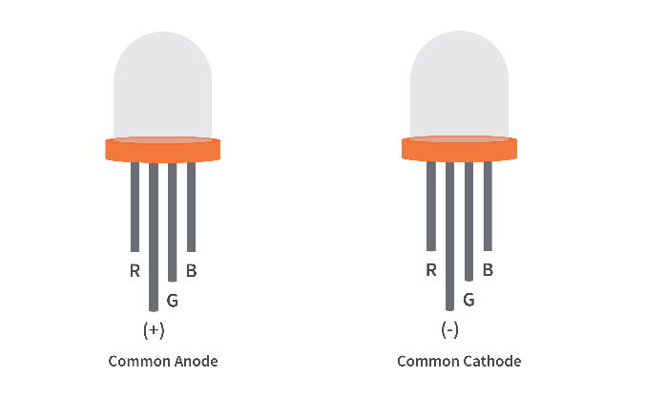

* + Introduce IR and LDR sensors, explaining their functions and digital output signals.

1. **Circuit Building:**
   * Demonstrate how to connect the IR sensor, LDR sensor, and RGB LED to the Arduino Uno on a breadboard.
   * Emphasize the importance of resistors for current limiting.
2. **Code Explanation and Implementation:**
   * Explain the provided Arduino code, focusing on digital input and output control.
   * Demonstrate how to upload the code to the Arduino and observe the RGB LED's behavior.
3. **Hands-On Activity:**
   * Students build the circuit and upload the code.
   * Students experiment with the sensors to observe the RGB LED's color changes.
   * Students modify the code to change color combinations or add additional sensor responses.
4. **Discussion and Applications:**
   * Discuss real-world applications of RGB LEDs, IR sensors, and LDR sensors.
   * Encourage students to brainstorm creative applications for the project.

**Detailed Explanation:**

* **RGB LED:**
  + An RGB LED combines red, green, and blue LEDs in a single package.
  + Common cathode LEDs require a HIGH signal to turn on a color, while common anode LEDs require a LOW signal.
* **IR Sensor:**
  + Detects infrared light and outputs a digital signal (LOW when an object is detected).
* **LDR Sensor:**
  + Detects light levels and outputs a digital signal (LOW in darkness, depending on the module).

**Circuit Components:**

* 1 x Arduino Uno
* 1 x RGB LED (Common Cathode)
* 3 x 220Ω Resistors
* 1 x Digital IR Sensor Module
* 1 x Digital LDR Sensor Module
* Breadboard & Jumper Wires
* USB Cable (for power and uploading code)

**Circuit Connections:**

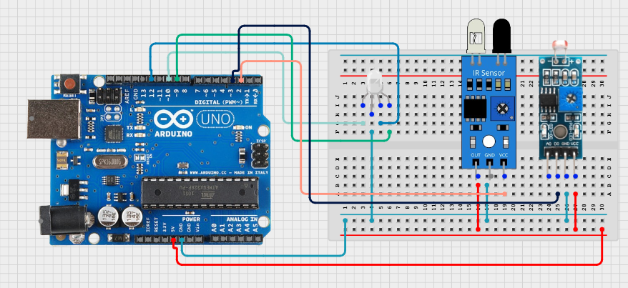

1. **IR Sensor:**
   * VCC to Arduino 5V
   * GND to Arduino GND
   * Digital output to Arduino pin 2
2. **LDR Sensor:**
   * VCC to Arduino 5V
   * GND to Arduino GND
   * Digital output to Arduino pin 3
3. **RGB LED:**
   * Common cathode to Arduino GND
   * Red pin to Arduino pin 10 (through a 220Ω resistor)
   * Green pin to Arduino pin 11 (through a 220Ω resistor)
   * Blue pin to arduino pin 9 (through a 220 ohm resistor)

**Example Code:**

void setup() {

pinMode(2, INPUT);

pinMode(3, INPUT);

pinMode(10, OUTPUT);

pinMode(11, OUTPUT);

pinMode(9, OUTPUT);

Serial.begin(9600);

}

void loop() {

if (digitalRead(2) == LOW) {

digitalWrite(10, HIGH);

digitalWrite(11, LOW);

digitalWrite(9, LOW);

} else if (digitalRead(3) == LOW) {

digitalWrite(10, LOW);

digitalWrite(11, HIGH);

digitalWrite(9, LOW);

} else {

digitalWrite(10, LOW);

digitalWrite(11, LOW);

digitalWrite(9, HIGH);

}

Serial.print("LDR: ");

Serial.println(digitalRead(3));

delay(100);

}

**How the Code Works:**

1. **Pin Configuration:**
   * Sets the sensor pins as inputs and the RGB LED pins as outputs.
2. **Sensor Readings:**
   * Reads the digital states of the IR and LDR sensors.
3. **RGB LED Control:**
   * Changes the RGB LED color based on sensor input.
4. **Serial Output:**
   * Prints the LDR sensor's digital state to the Serial Monitor.

**Task: Modifying Color Combinations**

* Students modify the code to create different color combinations based on sensor input.
* Students experiment with adding more sensor-triggered color changes.

**How It Works:**

* The code uses digital input to trigger specific RGB LED color outputs.
* Students learn how to map sensor input to visual output.

**Hands-On Activity:**

1. **Build the circuit.**
2. **Upload the code.**
3. **Observe the RGB LED's response to sensor input.**
4. **Modify the code to create new color combinations.**
5. **Experiment with different sensor inputs.**

**Discussion and Applications:**

* **Real-World Uses:**
  + Interactive displays
  + Smart lighting
  + Security systems
  + Robotics

**Hands-On Activity**

1. Build the circuit on a breadboard following the connection diagram.
2. Upload the code to Arduino Uno.
3. Observe the RGB LED cycle through different colors.
4. Modify the code to create custom colors by changing the PWM values.
5. Try a fading effect using for loops to gradually increase or decrease brightness.

**Discussion and Applications**

**Real-World Uses:**

* Smart Lighting – RGB LEDs are used in home automation for customizable lighting.
* Displays & Indicators – Traffic signals, electronic signs, and decorative lighting.
* Gaming & Ambience Lighting – RGB setups in keyboards, gaming consoles, and ambient room lighting.

**13: Motor Drive – Forward and Backward**

**Objective: To expand on motor control and integrate it with a line follower robot, enabling forward, backward, and line-following functionality.**

**Basic Motor Control (Forward & Backward)**

**Components:**

* Arduino Uno (or similar microcontroller)
* 2 x DC Motors
* Motor Driver (e.g., L298N)
* Power Supply (for motors)
* Jumper Wires

**Circuit Connections (Using L298N):**

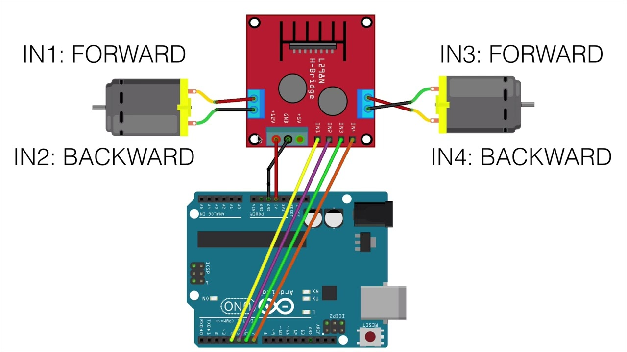

* **L298N to Arduino:** 
  + L298N EN A → Arduino PWM pin (e.g., 9)
  + L298N IN1 → Arduino digital pin (e.g., 8)
  + L298N IN2 → Arduino digital pin (e.g., 7)
  + L298N EN B → Arduino PWM pin (e.g., 10)
  + L298N IN3 → Arduino digital pin (e.g., 11)
  + L298N IN4 → Arduino digital pin (e.g., 12)
  + L298N 5V --> Arduino 5V
  + L298N GND --> Arduino GND
* **L298N to Motors:** 
  + L298N Output 1 → Motor 1 terminal 1
  + L298N Output 2 → Motor 1 terminal 2
  + L298N Output 3 → Motor 2 terminal 1
  + L298N Output 4 → Motor 2 terminal 2
* **L298N Power:** 
  + L298N VMS → Motor Power Supply (+)
  + L298N GND → Motor Power Supply (-)

**Example Code :**

void setup() {

pinMode(8, OUTPUT);

pinMode(7, OUTPUT);

pinMode(11, OUTPUT);

pinMode(12, OUTPUT);

}

void loop() {

// Forward

digitalWrite(8, HIGH);

digitalWrite(7, LOW);

digitalWrite(11, HIGH);

digitalWrite(12, LOW);

delay(2000);

// Backward

digitalWrite(8, LOW);

digitalWrite(7, HIGH);

digitalWrite(11, LOW);

digitalWrite(12, HIGH);

delay(2000);

// Stop

digitalWrite(8, LOW);

digitalWrite(7, LOW);

digitalWrite(11, LOW);

digitalWrite(12, LOW);

delay(1000);

}

**Discussion:**

* Explain the working principle of IR sensors and their use in line detection.
* Discuss the logic behind the line following algorithm.
* Discuss the importance of sensor placement and calibration.
* Discuss the benefits and drawbacks of using IR sensors for line following.
* Discuss the effects of ambient light on the IR sensors.

**Applications:**

* Automated guided vehicles (AGVs) in industrial settings.
* Robotic vacuum cleaners.
* Educational robots for teaching robotics and programming.
* Automated delivery robots.

**Class-14: Ultrasonic Sensor and Obstacle Avoidance Robot**

**Objective: Teach students how to use an ultrasonic sensor to detect obstacles and build an obstacle avoidance robot.**

* **Activity**:
  + Show a **picture of an ultrasonic sensor** and explain how it works.

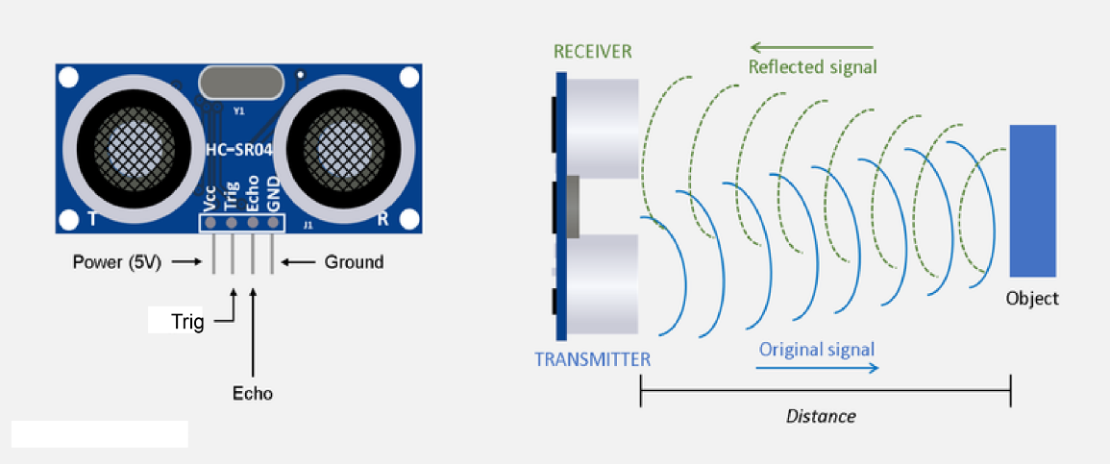

* + Demonstrate how to build the circuit and write the code.

**Detailed Explanation**

**1. What is an Ultrasonic Sensor?**

* **Definition**: An ultrasonic sensor is a device that measures distance by emitting sound waves and measuring the time it takes for the waves to reflect back.
* **How It Works**:
  + The sensor emits a high-frequency sound wave.
  + The sound wave reflects off an object and returns to the sensor.
  + The sensor calculates the distance based on the time taken for the sound wave to return.

**2. Obstacle Avoidance Robot Circuit Setup**

* **Components Needed**:
  + 1 x Ultrasonic Sensor (HC-SR04).
  + 1 x Motor Driver (L298N).
  + 2 x DC Motors.
  + 1 x Arduino Uno.
  + 1 x Breadboard.
  + Connecting wires.
* **Circuit Diagram**:

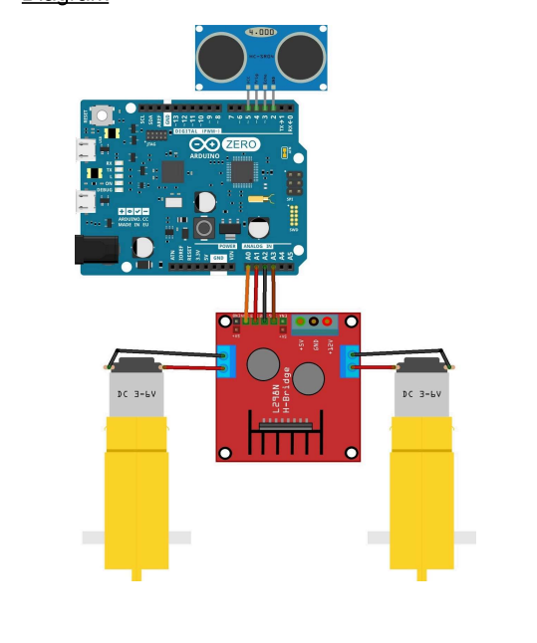

* + **Ultrasonic Sensor**:
    - Connect the **VCC** pin to **5V** on the Arduino.
    - Connect the **GND** pin to **GND** on the Arduino.
    - Connect the **TRIG** pin to **digital pin 9**.
    - Connect the **ECHO** pin to **digital pin 10**.
  + **Motor Driver**:
    - Connect the **IN1** pin to **digital pin 2**.
    - Connect the **IN2** pin to **digital pin 3**.
    - Connect the **IN3** pin to **digital pin 4**.
    - Connect the **IN4** pin to **digital pin 5**.
    - Connect the **ENA** pin to **PWM pin 6**.
    - Connect the **ENB** pin to **PWM pin 7**.
    - Connect the **VCC** pin to **5V** on the Arduino.
    - Connect the **GND** pin to **GND** on the Arduino.
    - Connect the **OUT1** and **OUT2** pins to **Motor 1**.
    - Connect the **OUT3** and **OUT4** pins to **Motor 2**.

**3. How It Works**

* The ultrasonic sensor detects obstacles by measuring the distance to the nearest object.
* If an obstacle is detected within a certain range (e.g., 20 cm), the robot stops, moves backward, and turns left to avoid the obstacle.
* If no obstacle is detected, the robot moves forward.

**4. Hands-On Activity**

1. **Build the Circuit**:
   * Show students how to connect the ultrasonic sensor, motor driver, and motors to the Arduino.
   * Use a **picture of the circuit** as a reference.
2. **Upload the Code**:
   * Guide students through writing and uploading the code.
   * **Example Code**:

#include <Bonezegel_HCSR04.h>

// Define pins for the ultrasonic sensor

#define TRIGGER_PIN 9

#define ECHO_PIN 10

#define MAX_DISTANCE 200 // Maximum distance to measure (in cm)

// Define pins for the motor driver

#define MOTOR1_FORWARD 2

#define MOTOR1_BACKWARD 3

#define MOTOR2_FORWARD 4

#define MOTOR2_BACKWARD 5

// Create an instance of the HC-SR04 sensor

HC_SR04 sonar(TRIGGER_PIN, ECHO_PIN);

void setup() {

// Initialize motor pins

pinMode(MOTOR1_FORWARD, OUTPUT);

pinMode(MOTOR1_BACKWARD, OUTPUT);

pinMode(MOTOR2_FORWARD, OUTPUT);

pinMode(MOTOR2_BACKWARD, OUTPUT);

Serial.begin(9600); // Start serial communication for debugging

}

void loop() {

delay(50); // Wait a bit between measurements

int distance = sonar.getDistance(); // Measure distance in cm

Serial.print("Distance: ");

Serial.print(distance);

Serial.println(" cm");

if (distance > 0 && distance < 20) { // If an obstacle is detected within 20 cm

// Stop the robot

stopMotors();

delay(500); // Wait for half a second

// Move backward

moveBackward();

delay(500); // Move backward for 0.5 seconds

// Turn left

turnLeft();

delay(500); // Turn left for 0.5 seconds

// Stop and move forward

stopMotors();

delay(500); // Wait for 0.5 seconds

} else {

// Move forward

moveForward();

}

}

// Function to move the robot forward

void moveForward() {

digitalWrite(MOTOR1_FORWARD, HIGH);

digitalWrite(MOTOR1_BACKWARD, LOW);

digitalWrite(MOTOR2_FORWARD, HIGH);

digitalWrite(MOTOR2_BACKWARD, LOW);

}

// Function to move the robot backward

void moveBackward() {

digitalWrite(MOTOR1_FORWARD, LOW);

digitalWrite(MOTOR1_BACKWARD, HIGH);

digitalWrite(MOTOR2_FORWARD, LOW);

digitalWrite(MOTOR2_BACKWARD, HIGH);

}

// Function to turn the robot left

void turnLeft() {

digitalWrite(MOTOR1_FORWARD, LOW);

digitalWrite(MOTOR1_BACKWARD, HIGH);

digitalWrite(MOTOR2_FORWARD, HIGH);

digitalWrite(MOTOR2_BACKWARD, LOW);

}

// Function to stop the motors

void stopMotors() {

digitalWrite(MOTOR1_FORWARD, LOW);

digitalWrite(MOTOR1_BACKWARD, LOW);

digitalWrite(MOTOR2_FORWARD, LOW);

digitalWrite(MOTOR2_BACKWARD, LOW);

}

1. **Test the Circuit**:
   * Place an obstacle in front of the robot and observe how it stops, moves backward, and turns left.
   * Remove the obstacle and observe the robot moving forward.

* **Picture of the Circuit**:
  + Display a **photo of the breadboard setup** with labeled components.

**6. Discussion and Applications**

* **Real-World Applications**:
  + Autonomous vehicles.
  + Robotics in manufacturing.
  + Security systems.
* **Discussion Questions**:
  + What happens if you change the obstacle detection range in the code?
  + How can you modify the code to make the robot turn right instead of left?
  + Can you think of other sensors that could be used for obstacle detection?

**15.Hand Follower Robot and Line Follower Robot**

This lesson plan provides a detailed and engaging approach to teaching students how to build and program a **Hand Follower Robot** and a **Line Follower Robot** using IR sensors. It includes step-by-step instructions, visual aids, and real-world examples to ensure students understand the concepts and can apply them in practical scenarios.

**Hand Follower Robot**

**Objective:** Teach students how to build and program a hand follower robot using a single IR sensor.

**Activity:**

* Show a picture of a hand follower robot and explain how it works.

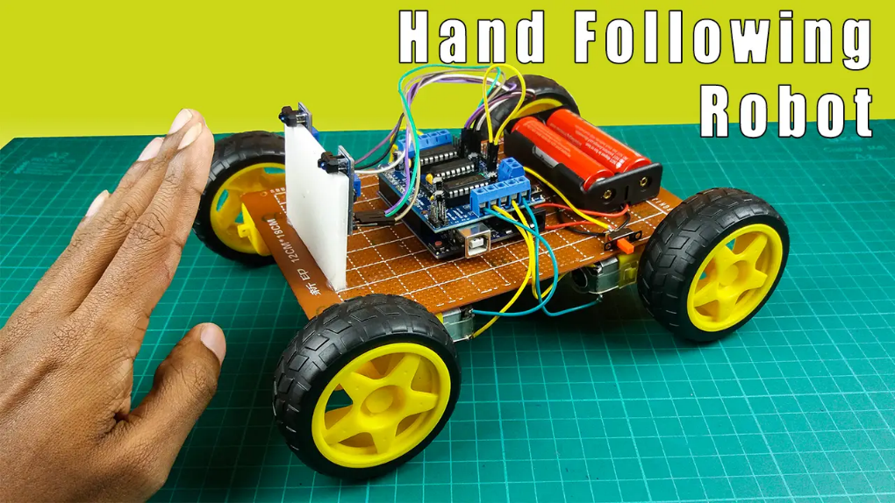

* Demonstrate how to build the circuit and write the code.
* Visual Aid: Display a diagram of the hand follower robot circuit with labels.

**Detailed Explanation**

**1. What is a Hand Follower Robot?**

* **Definition:** A hand follower robot is a robot that follows a hand or object using an IR sensor to detect proximity.
* **How It Works (with one sensor):**
  + The IR sensor emits infrared light and measures how much is reflected back. The closer an object is, the stronger the reflection.
  + The robot adjusts its movement based on the sensor reading. If the hand is close, it moves. If the hand is far, it stops.

**2. Circuit Setup**

**Components Needed:**

* 1 x IR Sensor
* 4 x DC Motors
* 1 x Motor Driver (L298N)
* 1 x Arduino Uno
* Connecting wires

**Circuit Diagram:**

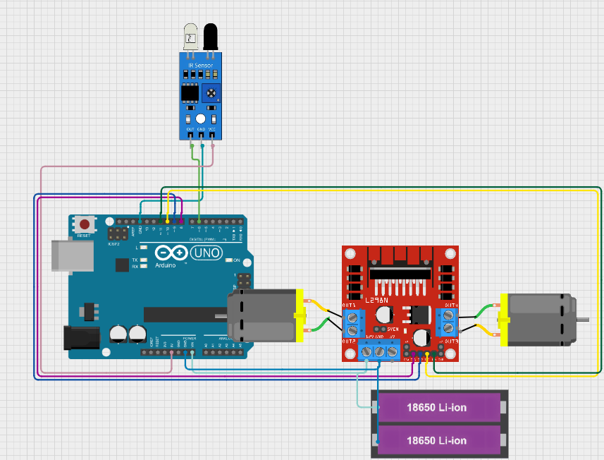

* **IR Sensor:**
  + Connect the VCC pin to 5V on the Arduino.
  + Connect the GND pin to GND on the Arduino.
  + Connect the OUT pin to digitalpin 6.
* **Motor Driver:** (Refer to the Line Follower Robot lesson plan if needed)
  + Connect IN1 to digital pin 8.
  + Connect IN2 to digital pin 9.
  + Connect IN3 to digital pin 10.
  + Connect IN4 to digital pin 11.
  + Connect VCC to 5V on the Arduino.
  + Connect GND to GND on the Arduino.
  + Connect OUT1 and OUT2 to Motor 1.
  + Connect OUT3 and OUT4 to Motor 2.

**3. Hands-On Activity**

**Build the Circuit:**

* Show students how to connect the IR sensor, motor driver, and motors to the Arduino.
* Use a picture of the circuit as a reference.

**Upload the Code:**

* Guide students through writing and uploading the code.

**Example Code:**

void setup() {

pinMode(8, OUTPUT);

pinMode(9, OUTPUT);

pinMode(10, OUTPUT);

pinMode(11, OUTPUT);

pinMode(6, INPUT);

}

void loop() {

if (digitalRead(6) == LOW) { // Hand detected

digitalWrite(8, HIGH);

digitalWrite(9, LOW);

digitalWrite(10, HIGH);

digitalWrite(11, LOW);

} else {

digitalWrite(8, LOW);

digitalWrite(9, LOW);

digitalWrite(10, LOW);

digitalWrite(11, LOW);

}

}

**4. Test the Circuit:**

* Move your hand closer and further from the IR sensor to test the robot's response.

**5. Discussion and Applications**

* **Real-World Applications:**
  + Touchless interactive displays
  + Proximity sensors in devices
  + Simple robotic navigation
* **Discussion Questions:**
  + How can we make the robot more sensitive or less sensitive to the hand?
  + What are the limitations of using only one sensor for hand following?
  + How could we improve the robot's ability to follow a hand with one sensor? (Hint: Using timing and delays to detect hand movement.)

**Line Follower Robot**

**Objective:** Teach students how to build and program a line-following robot using a single IR sensor.

**Activity:**

* Show a picture of a line-following robot and explain how it works.

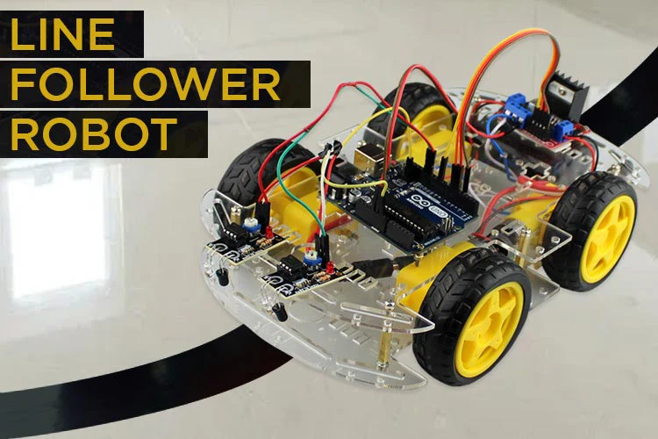

* Demonstrate how to build the circuit and write the code.
* Visual Aid: Display a diagram of the line-following robot circuit with labels.

**Detailed Explanation**

**1. What is a Line Following Robot?**

* **Definition:** A line-following robot is an autonomous robot that follows a specific path (usually a black line on a white surface) using an IR sensor.
* **How It Works:** * The IR sensor detects the line by emitting infrared light and measuring the reflection.
  + The robot adjusts its movement based on the sensor readings to stay on the line.

**2. Circuit Setup**

**Components Needed:**

* 1 x Arduino UNO
* 2 x DC Motors (12V)
* 1 x Dual H-Bridge Motor Driver (L298N)
* 1 x IR Sensor
* 1 x Battery Holder (18650 x 2)
* Connecting wires

**Circuit Diagram:**



* **IR Sensor:**
  + Connect the VCC pin to 5V on the Arduino.
  + Connect the GND pin to GND on the Arduino.
  + Connect the OUT pin to digital pin 6.
* **Motor Driver:**
  + Connect IN1 to digital pin 8.
  + Connect IN2 to digital pin 9.
  + Connect IN3 to digital pin 10.
  + Connect IN4 to digital pin 11.
  + Connect VCC to 5V on the Arduino.
  + Connect GND to GND on the Arduino.
  + Connect OUT1 and OUT2 to Motor 1.
  + Connect OUT3 and OUT4 to Motor 2.

**3. Hands-On Activity**

**Build the Circuit:**

* Show students how to connect the IR sensor, motor driver, and motors to the Arduino.
* Use a picture of the circuit as a reference.

**Upload the Code:**

* Guide students through writing and uploading the code.

**Example Code:**

void setup() {

pinMode(8, OUTPUT);

pinMode(9, OUTPUT);

pinMode(10, OUTPUT);

pinMode(11, OUTPUT);

pinMode(6, INPUT);

delay(5000);

}

void loop() {

if (digitalRead(6) == LOW) { // Line detected

digitalWrite(8, HIGH);

digitalWrite(9, LOW);

digitalWrite(10, HIGH);

digitalWrite(11, LOW);

} else { // No line detected, turn slightly

digitalWrite(8, HIGH);

digitalWrite(9, LOW);

digitalWrite(10, LOW);

digitalWrite(11, HIGH);

delay(20);

}

}

**Test the Circuit:**

* Place the robot on a black line on a white surface and observe its movement.

**5. Discussion and Applications**

* **Real-World Applications**:
  + Automated warehouses and factories.
  + Educational tools.
* **Discussion Questions**:
  + What happens if you change the sensitivity of the IR sensors?
  + How can you modify the code to make the robot move faster or slower?
  + Can you think of other applications for this robot?

**16. Light Following Robot**

**Objective:** Teach students how to build and program a light-following robot using a single LDR module and digital input, without using the enable pins for motor speed control.

**Activity:**

* Show a picture of a light-following robot and explain how it works.

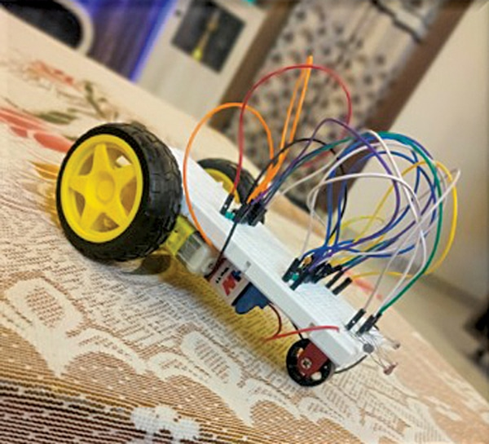

* Demonstrate how to build the circuit and write the code.
* Visual Aid: Display a diagram of the light-following robot circuit with labels.

**Detailed Explanation**

**1. What is a Light Following Robot?**

* **Definition:** A light-following robot is an autonomous robot that moves towards a light source using an LDR module.
* **How It Works (with one sensor):** * The LDR module detects the intensity of light. A brighter light will result in a lower resistance reading from the LDR.
  + The robot uses this reading to determine if it should move forward (towards the light) or turn to search for the light.

**2. Circuit Setup**

**Components Needed:**

* 1 x Arduino UNO
* 2 x DC Motors
* 1 x L298N Motor Driver Module
* 1 x LDR Module
* 1 x 12V Battery
* 1 x Car Chassis
* 1 x On-Off Switch
* 1 x DC Female Connector Jack
* Connecting wires
* Soldering iron
* Solder wire
* Hot Glue Gun

**Circuit Diagram:**

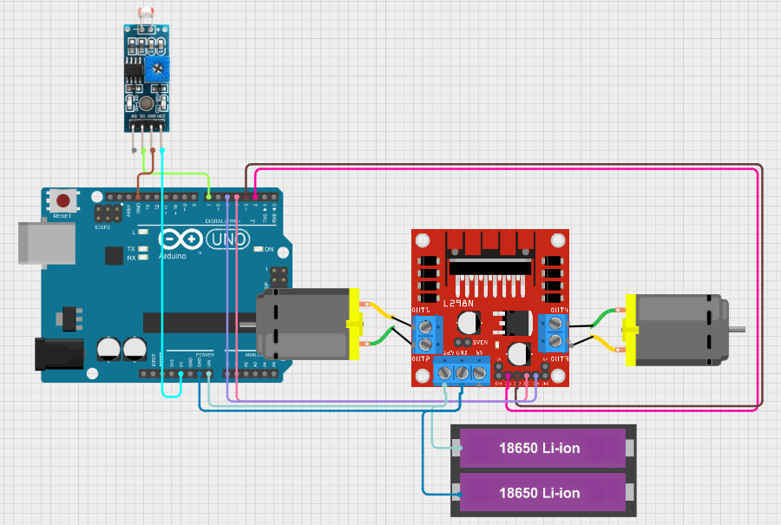

* **LDR Module:**
  + Connect the VCC pin of the LDR module to 5V on the Arduino.
  + Connect the GND pin of the LDR module to GND on the Arduino.
  + Connect the DO pin of the LDR module to digital pin 7.
* **Motor Driver:** * Connect the IN1 pin to digital pin 2.
  + Connect the IN2 pin to digital pin 3.
  + Connect the IN3 pin to digital pin 4.
  + Connect the IN4 pin to digital pin 5.
  + Connect the VCC pin to 12V on the battery.
  + Connect the GND pin to GND on the battery and Arduino.
  + Connect the OUT1 and OUT2 pins to Motor 1.
  + Connect the OUT3 and OUT4 pins to Motor 2.

**3. Hands-On Activity**

**Build the Circuit:**

* Show students how to connect the LDR module, motor driver, and motors to the Arduino.
* Use a picture of the circuit as a reference.

**Upload the Code:**

* Guide students through writing and uploading the code.

**Example Code:**

void setup() {

pinMode(2, OUTPUT);

pinMode(3, OUTPUT);

pinMode(4, OUTPUT);

pinMode(5, OUTPUT);

pinMode(7, INPUT); // LDR module on digital pin 7

}

void loop() {

if (digitalRead(7) == LOW) { // Light detected

// Move forward

digitalWrite(2, HIGH);

digitalWrite(3, LOW);

digitalWrite(4, LOW);

digitalWrite(5, HIGH);

} else { // No light detected, turn to search

// Turn right (adjust turning direction as needed)

digitalWrite(2, LOW);

digitalWrite(3, HIGH);

digitalWrite(4, LOW);

digitalWrite(5, HIGH);

}

delay(100); // Small delay for smoother movement

}

**Test the Circuit:**

* Shine a light on the LDR module and observe how the robot moves towards the light.
* Experiment with the robot's behavior in different lighting conditions.

**5. Discussion and Applications**

* **Real-World Applications:**
  + Simple solar trackers (with limitations)
  + Light-sensitive security systems (basic)
  + Basic robotic navigation (limited control)
* **Discussion Questions:**
  + How can we adjust the code to change the robot's sensitivity to light?
  + What are the limitations of using only one sensor for light following?
  + How could we improve the robot's ability to follow a light source with one sensor? (Hint: More complex turning patterns or timing-based movement)

**17. Edge Detection Robot**

**Objective: Teach students how to build and program an edge detection robot using IR sensors.**

* **Activity**:
  + Show a **picture of an edge detection robot** and explain how it works.

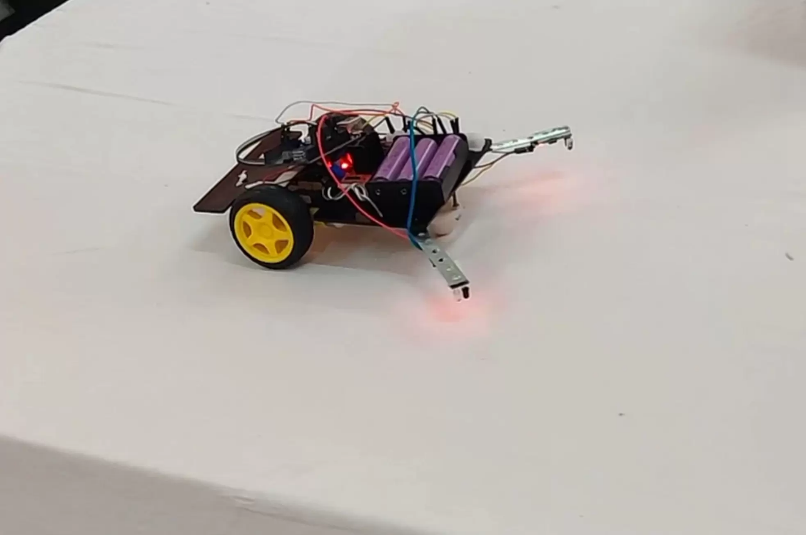

* + Demonstrate how to build the circuit and write the code.

**Detailed Explanation**

**1. What is an Edge Detection Robot?**

* **Definition**: An edge detection robot is an autonomous robot that detects edges (such as the edge of a table or platform) and avoids falling off by reversing or changing direction.
* **How It Works**:
  + The robot uses IR sensors to detect the presence or absence of a surface beneath it.
  + When the sensors detect an edge (no surface), the robot stops, reverses, or turns to avoid falling.

**2. Circuit Setup**

* **Components Needed**:
  + 1 x Arduino UNO.
  + 2 x DC Motors.
  + 1 x L298N Motor Driver Module.
  + 2 x IR Sensors (for edge detection).
  + 1 x 12V Battery.
  + 1 x Car Chassis.
  + 1 x On-Off Switch.
  + 1 x DC Female Connector Jack.
  + Connecting wires.
  + Soldering iron.
  + Solder wire.
  + Hot Melt Glue Gun.
* **Circuit Diagram**:

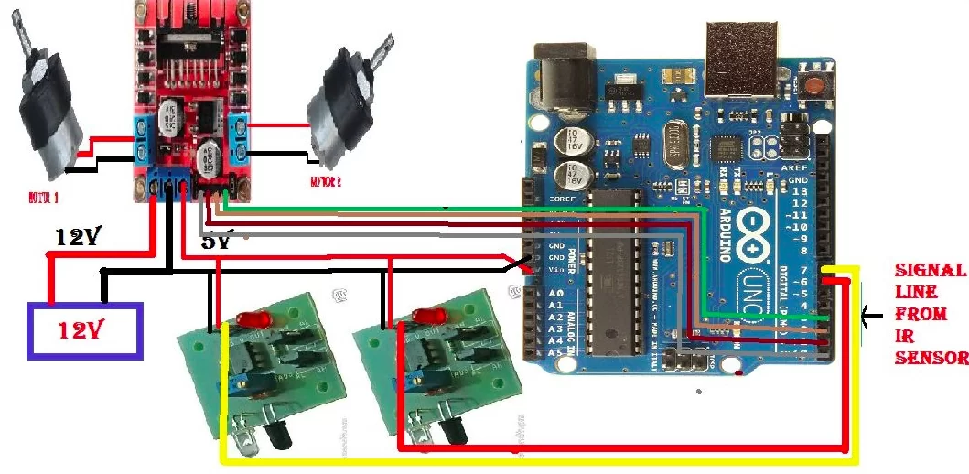

* + **IR Sensors**:
    - Connect the **VCC** pin of both IR sensors to **5V** on the Arduino.
    - Connect the **GND** pin of both IR sensors to **GND** on the Arduino.
    - Connect the **OUT** pin of the right IR sensor to **digital pin 7**.
    - Connect the **OUT** pin of the left IR sensor to **digital pin 8**.
  + **Motor Driver**:
    - Connect the **IN1** pin to **digital pin 2**.
    - Connect the **IN2** pin to **digital pin 3**.
    - Connect the **IN3** pin to **digital pin 4**.
    - Connect the **IN4** pin to **digital pin 5**.
    - Connect the **ENA** pin to **PWM pin 10**.
    - Connect the **ENB** pin to **PWM pin 11**.
    - Connect the **VCC** pin to **12V** on the battery.
    - Connect the **GND** pin to **GND** on the battery and Arduino.
    - Connect the **OUT1** and **OUT2** pins to **Motor 1**.
    - Connect the **OUT3** and **OUT4** pins to **Motor 2**.

**3. Hands-On Activity**

1. **Build the Circuit**:
   * Show students how to connect the IR sensors, motor driver, and motors to the Arduino.
   * Use a **picture of the circuit** as a reference.
2. **Upload the Code**:
   * Guide students through writing and uploading the code.
   * **Example Code**:

void setup() {

Serial.begin(9600);

pinMode(2, OUTPUT);

pinMode(3, OUTPUT);

pinMode(4, OUTPUT);

pinMode(5, OUTPUT);

pinMode(10, OUTPUT);

pinMode(11, OUTPUT);

analogWrite(10, 60);

analogWrite(11, 60);

}

void loop() {

int ir_right = digitalRead(7);

int ir_left = digitalRead(8);

if (ir_right == HIGH && ir_left == HIGH) {

Serial.println("Moving Forward");

digitalWrite(2, HIGH);

digitalWrite(3, LOW);

digitalWrite(4, HIGH);

digitalWrite(5, LOW);

} else if (ir_right == LOW && ir_left == HIGH) {

Serial.println("Edge Detected on Right - Turning Left");

digitalWrite(2, HIGH);

digitalWrite(3, LOW);

digitalWrite(4, LOW);

digitalWrite(5, HIGH);

delay(500);

} else if (ir_right == HIGH && ir_left == LOW) {

Serial.println("Edge Detected on Left - Turning Right");

digitalWrite(2, LOW);

digitalWrite(3, HIGH);

digitalWrite(4, HIGH);

digitalWrite(5, LOW);

delay(500);

} else if (ir_right == LOW && ir_left == LOW) {

Serial.println("Edge Detected on Both Sides - Stopping and Reversing");

digitalWrite(2, LOW);

digitalWrite(3, LOW);

digitalWrite(4, LOW);

digitalWrite(5, LOW);

delay(500);

digitalWrite(2, LOW);

digitalWrite(3, HIGH);

digitalWrite(4, LOW);

digitalWrite(5, HIGH);

delay(1000);

}

}

1. **Test the Circuit**:
   * Place the robot on a table and observe how it detects the edge and avoids falling off.

**5. Discussion and Applications**

* **Real-World Applications**:
  + Autonomous cleaning robots.
  + Industrial robots for navigating platforms.
  + Educational tools for learning robotics and programming.
* **Discussion Questions**:
  + What happens if you change the sensitivity of the IR sensors?
  + How can you modify the code to make the robot move faster or slower?
  + Can you think of other applications for this robot?

**18. Advanced Motor Applications in Real Life**

**Objective**: Explore advanced motor applications in real-world scenarios, focusing on theory and practical use cases.

**1. Types of Motors in Advanced Applications**

Advanced motor applications often involve the use of specialized motors, including:

* **DC Motors**: Used for simple motion control in robotics and automation.

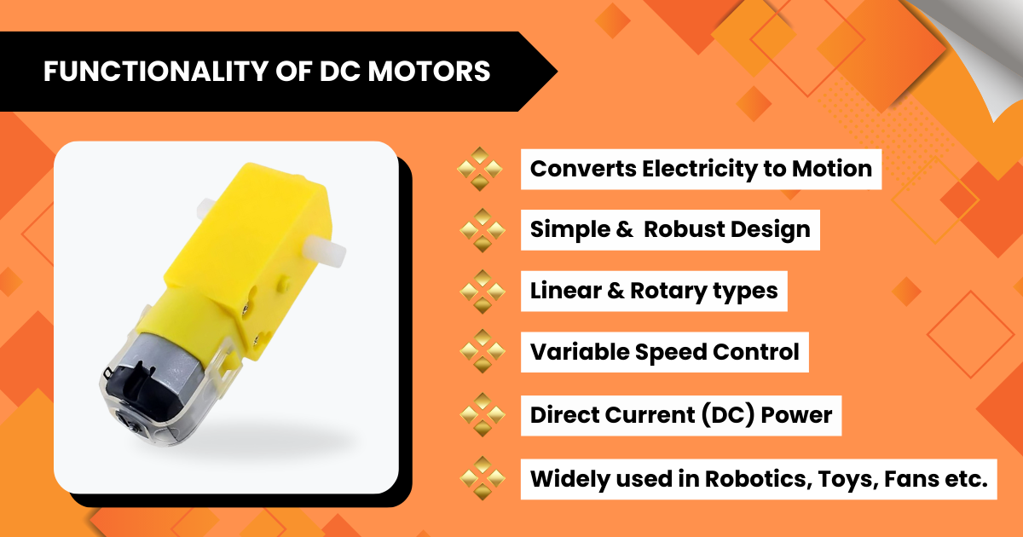

* **Stepper Motors**: Provide precise control of position and speed, ideal for CNC machines and 3D printers.

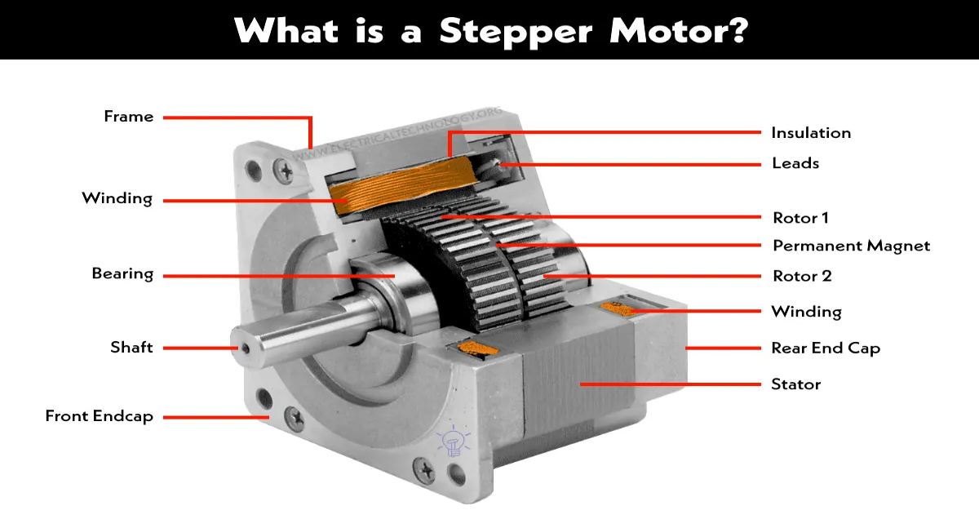

* **Servo Motors**: Offer angular control, commonly used in robotics, camera gimbals, and RC vehicles.

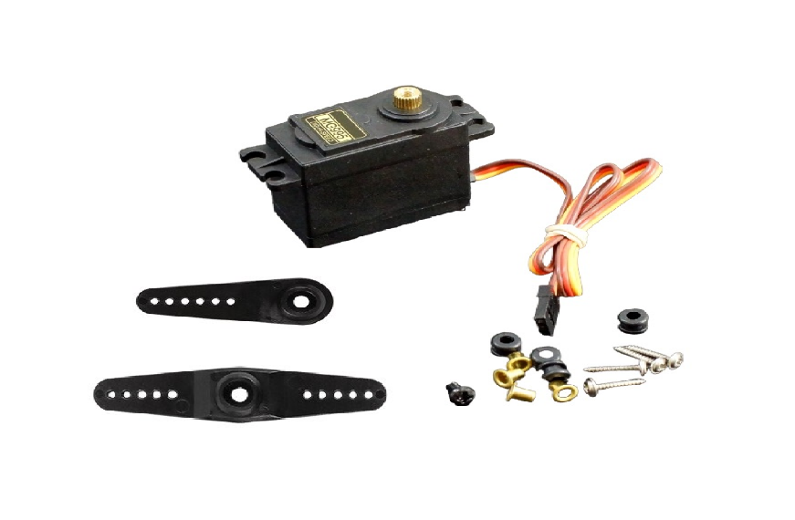

* **Brushless DC Motors (BLDC)**: High efficiency and power, used in drones, electric vehicles, and industrial machinery.

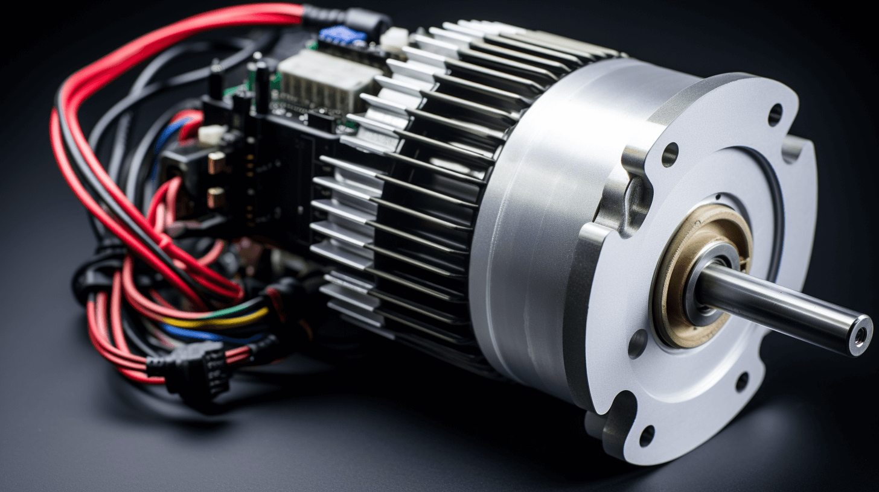

* **Linear Motors**: Provide direct linear motion, used in high-speed trains and precision manufacturing.

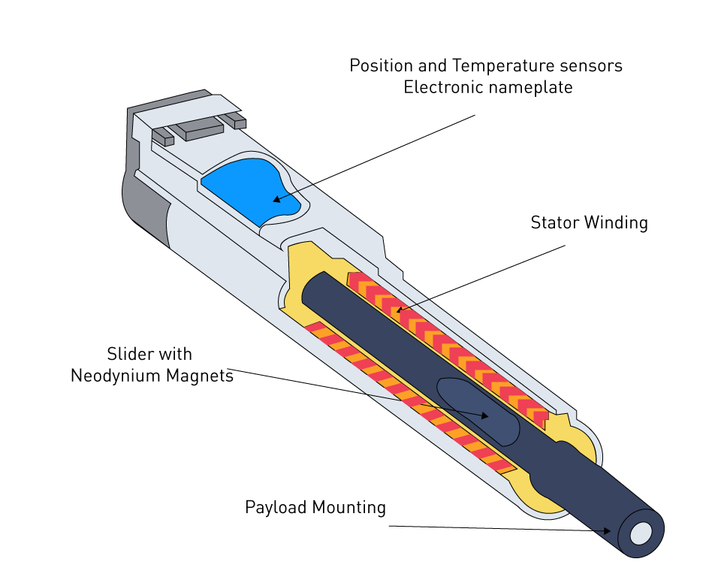

**2. Advanced Motor Control Techniques**

* **PWM (Pulse Width Modulation)**: Controls motor speed by varying the duty cycle of the signal.
* **PID Control (Proportional-Integral-Derivative)**: Maintains precise control of speed, position, or torque using feedback.
* **Closed-Loop Control**: Uses sensors (e.g., encoders, Hall effect sensors) to provide real-time feedback for accurate control.
* **Field-Oriented Control (FOC)**: Advanced technique for BLDC motors to achieve smooth and efficient operation.
* **Microstepping**: Divides each step of a stepper motor into smaller steps for smoother motion and higher resolution.

**3. Real-Life Applications of Advanced Motors**

**a. Robotics**

* **Industrial Robots**: Use servo and stepper motors for precise movement in assembly lines.
* **Humanoid Robots**: Employ advanced motor control for lifelike motion and balance.
* **Autonomous Mobile Robots (AMRs)**: Use DC or BLDC motors for navigation and payload transport.

**b. Automotive Industry**

* **Electric Vehicles (EVs)**: BLDC motors power the drivetrain, offering high efficiency and torque.
* **Advanced Driver-Assistance Systems (ADAS)**: Use servo motors for steering and braking systems.
* **Regenerative Braking**: Converts kinetic energy into electrical energy using motor control techniques.

**c. Aerospace and Drones**

* **Drones**: BLDC motors provide propulsion, with ESCs (Electronic Speed Controllers) for precise control.
* **Aircraft Actuators**: Servo motors control flaps, landing gear, and other moving parts.

**d. Manufacturing and Automation**

* **CNC Machines**: Stepper motors enable precise control of cutting tools.
* **Conveyor Systems**: Use DC motors with speed control for material handling.
* **Robotic Arms**: Servo and stepper motors provide accurate positioning for assembly and welding.

**e. Medical Devices**

* **Surgical Robots**: Use advanced motors for precise and minimally invasive procedures.
* **Prosthetics**: Employ servo and BLDC motors for natural movement.
* **Imaging Systems**: Stepper motors control the movement of MRI and CT scan components.

**f. Renewable Energy**

* **Wind Turbines**: Use advanced motors for pitch control and power generation.
* **Solar Tracking Systems**: Stepper motors adjust the angle of solar panels for maximum efficiency.

**g. Consumer Electronics**

* **Camera Gimbals**: Servo motors stabilize cameras for smooth video recording.
* **Home Appliances**: BLDC motors are used in washing machines, refrigerators, and vacuum cleaners for energy efficiency.

**4. Challenges in Advanced Motor Applications**

* **Heat Dissipation**: High-power motors generate heat, requiring efficient cooling systems.
* **Power Supply**: Ensuring sufficient current and voltage for high-performance motors.
* **Noise and Vibration**: Advanced control techniques are needed to minimize noise and vibration.
* **Real-Time Performance**: Achieving precise control requires low-latency systems and efficient algorithms.
* **Integration with IoT**: Connecting motors to IoT systems for remote monitoring and control.

**5. Future Trends in Motor Applications**

* **Smart Motors**: Integration of sensors and IoT for predictive maintenance and adaptive control.
* **Energy Efficiency**: Development of motors with higher efficiency and lower power consumption.
* **AI and Machine Learning**: Use of AI to optimize motor performance and predict failures.
* **Miniaturization**: Smaller, more powerful motors for portable and wearable devices.
* **Sustainable Materials**: Use of eco-friendly materials in motor manufacturing.

**7. Discussion and Applications**

**Discussion Questions**:

* How do advanced motors improve efficiency in electric vehicles?
* What are the benefits of using BLDC motors in drones?
* How can AI enhance motor control in industrial automation?
* What challenges arise when integrating motors with IoT systems?

**Real-World Applications**:

* Highlight the role of motors in emerging technologies like autonomous vehicles and smart factories.
* Discuss the impact of advanced motors on sustainability and energy efficiency.